Deschutes Hall Room Reservation System
Software Design Specification
Esmé Nadeau, Kate Spencer, Katie Trinh, Lily Spurgat
Price Girls
https://github.com/esme-nadeau/422-Price-Girls
Professor Juan Flores
October 16, 2025

Table of Contents
1. SDS Revision History 2
2. System Overview 2
3. Software Architecture 3
3.1 Components and their functionality 3
3.2 Module Interaction 4
3.3 Rationale for Architecture 5
4. Software Modules 7
4.1 Authentication & User Management 7
4.2 Reservation System 9
4.3 Room Database 11
4.4 Map View Interface 12
4.5 Calendar View 14
4.6 My Bookings Interface 15
4.7 Admin Dashboard 18
4.8 Email Service / Firebase Integration 19
5. Dynamic Models of Operational Scenarios (Use Cases) 20
6. References 21
7. Acknowledgments 22

SDS Revision History
Date | Author | Description
10-15-2025 | Lily Spurgat | Wrote sections 2.0-5.0
10-17-2025 | Kate Spencer | Reformatted, added table of contents, section 1.0
10-17-2025 | Lily Spurgat | Edited Section 3.0 and add details from last meeting with Juan
10-17-2025 | Esmé Nadeau | Finished section 5.0
11-09-2025 | Lily Spurgat | Updated Figures 1 and 2 and made minor changes

System Overview
The Deschutes Hall Room Reservation Website enables CS faculty, staff, and students to view, request, and manage room reservations with clear role-based permissions. The system focuses on preventing scheduling conflicts, simplifying approvals, and listing room details such as if a room has a whiteboard, TV, webcam, and the number of chairs to support informed bookings. The system provides a map-based room selection experience, an alternative calendar view for those who prefer the original system, a personal “My Bookings” area for modification and cancellation, an “All Bookings” page that provides a comprehensive view of every reservation in the building in a calendar format, and an administrator view to approve/deny bookings, set building hours, add/modify/delete current rooms, and potentially more as time allows.

Key improvements over the existing process include: allowing students to view availability, allowing direct edits and cancellations of self-made reservations (removing the need to email the systems administrator), saving user identity for faster booking, and clearer conflict handling and directly in the UI.

The high-level organization comprises:
(a) web UIs (Map View, Calendar View, My Bookings, Admin Dashboard including All Bookings)
(b) application services (Authentication & User Management, Reservation System, Email Service)
(c) data components (Room Database).
The backend is a Python/Flask application that handles HTTP requests, authorization, and business logic, and persists all data in Google Firebase’s Cloud Firestore. The frontend is implemented using Flask-rendered HTML templates with Bootstrap-styled CSS and JavaScript served from the Flask static directory.

Software Architecture

3.1 Components and their functionality
Booking side/client side
- Log-in
  - Allows users to log-in using their .uoregon account.
- All Bookings
  - This is the default page regardless if you are logged in or not that provides a comprehensive view of every reservation in the building in a calendar format. Varying level of information on specific bookings is dependent on user access level.
- My Bookings
  - Personal dashboard with booking widgets; supports edit and cancellation.
- Calendar View
  - Calendar-first scheduling for a selected room; shows open time slots and creates reservation requests.
  - Can reserve rooms after selecting an open time with a button, will send a reservation request to the reservation system or show error with recommended alternatives.
- Map View
  - Supports interactive map with selectable rooms, the ability to scroll through different times and floors of the building.
  - Visual map of rooms; highlights availability for the selected date; creates reservation requests.
  - Can reserve rooms after selecting an open time and room with a button, will send a reservation request to the reservation system or show error with recommended alternatives.
Admin
- Admin Tools Dashboard
  - Administrative tools to view all bookings, set building hours, edit rooms, approve/deny reservations, and manage permissions. Room for flexibility on what capabilities admin will have dependent on how much time allows.
Server side
- Reservation System
  - Creates/reads/updates/cancels reservations; checks conflicts and supports repeat reservations.
- Room Database
  - Stores room data (location, capacity, availability and features).
- Email Service
  - Sends confirmation and notification emails for creation and updates to reservations.

3.2 Module Interaction
When users first visit the Deschutes Hall Room Reservation System, they can freely view room availability across the calendar or map interfaces without logging in. This public view allows anyone to see when rooms are occupied or available, but not the details of who made a reservation or the purpose of the booking. These details are restricted to authenticated users, and vary depending on user level. To make a reservation, users must log in using their University of Oregon email credentials (@uoregon.edu). Once authenticated, the system classifies them as Students by default, and their access privileges can later be updated to Faculty or Admin through the admin dashboard. Once authenticated, users can interact with the system through the Map View, Calendar View, My Bookings, All Bookings, and Admin Dashboard pages depending on access level.
When a user submits a reservation request from the Map or Calendar view, the interface forwards the request to the Reservation System along with the user’s verified identity and role. The Reservation System then uses the Room Database for details such as capacity, features, and existing reservations. It checks for scheduling conflicts, validates that the request falls within building hours, and applies any relevant policies. If the request passes validation, the system creates or updates the reservation and assigns a status for example “Pending” for student requests that require approval or “Approved” for faculty and admin.
The Admin Tools dashboard enables administrators to review pending reservations, approve or deny requests, modify building hours or room information, and/update/remove users, and modify or delete bookings. These updates immediately affect system-wide availability rules stored in the Room Database. When changes occur like creating, updating, or canceling a reservation the Email Service automatically sends notifications to users and administrators, ensuring consistent communication and record-keeping.
The My Bookings interface allows users to view, modify, or cancel their reservations. Any updates are revalidated by the Reservation System to ensure they comply with current policies. Cancellations or edits that affect other users trigger appropriate notifications through the Email Service. For Faculty permissions this tab will have a toggle that when on shows All Bookings verses just the faculties personal bookings.
Together, these modules maintain a clear separation of responsibilities while working in synchronization. Authentication enforces security and role integrity; the Reservation System coordinates booking logic; the Room Database provides reliable data access; and the Email Service ensures users are informed of all status changes. Figures 1 and 2 illustrate these interactions, showing how data flows between components during a typical booking cycle.
3.3 Rationale for Architecture

The architectural design of the Deschutes Hall Room Reservation System was chosen to balance simplicity, maintainability, and scalability while meeting the functional needs of different user roles. The system’s primary goal is to allow users to securely log in, view available rooms, create and manage reservations, and receive updates or approvals without manual administrative intervention. To achieve this, the system is divided into modular components that separate user interaction, application logic, and data management.

A modular design was selected to clearly define responsibilities and reduce overlap between components. By separating the Authentication & User Management module from the Reservation System, the architecture ensures that security and business logic remain independent. Authentication is handled entirely by Firebase, which provides a reliable and scalable way to verify users and assign roles. This decision reduces potential errors in authorization, simplifies maintenance, and makes future updates to the authentication process easier to implement.

The remaining modules All Bookings, Map View, Calendar View, My Bookings, Admin Dashboard, and Room Database were kept independent for similar reasons. Each has a specific purpose that supports system usability and flexibility. Keeping them separate allows for parallel development and easier debugging while ensuring that changes to one interface or feature do not unintentionally affect others. For example, the Map and Calendar views both interact with the Reservation System but remain isolated in presentation and functionality, improving both user experience and maintainability.

Overall, this architecture was selected because it promotes clarity and scalability. Each component focuses on a single area of responsibility, making the system easier to test, extend, and secure. The use of Firebase for authentication, Flask for backend routing, and Bootstrap for the user interface creates a lightweight yet robust framework that supports both the immediate project goals and potential future expansion.
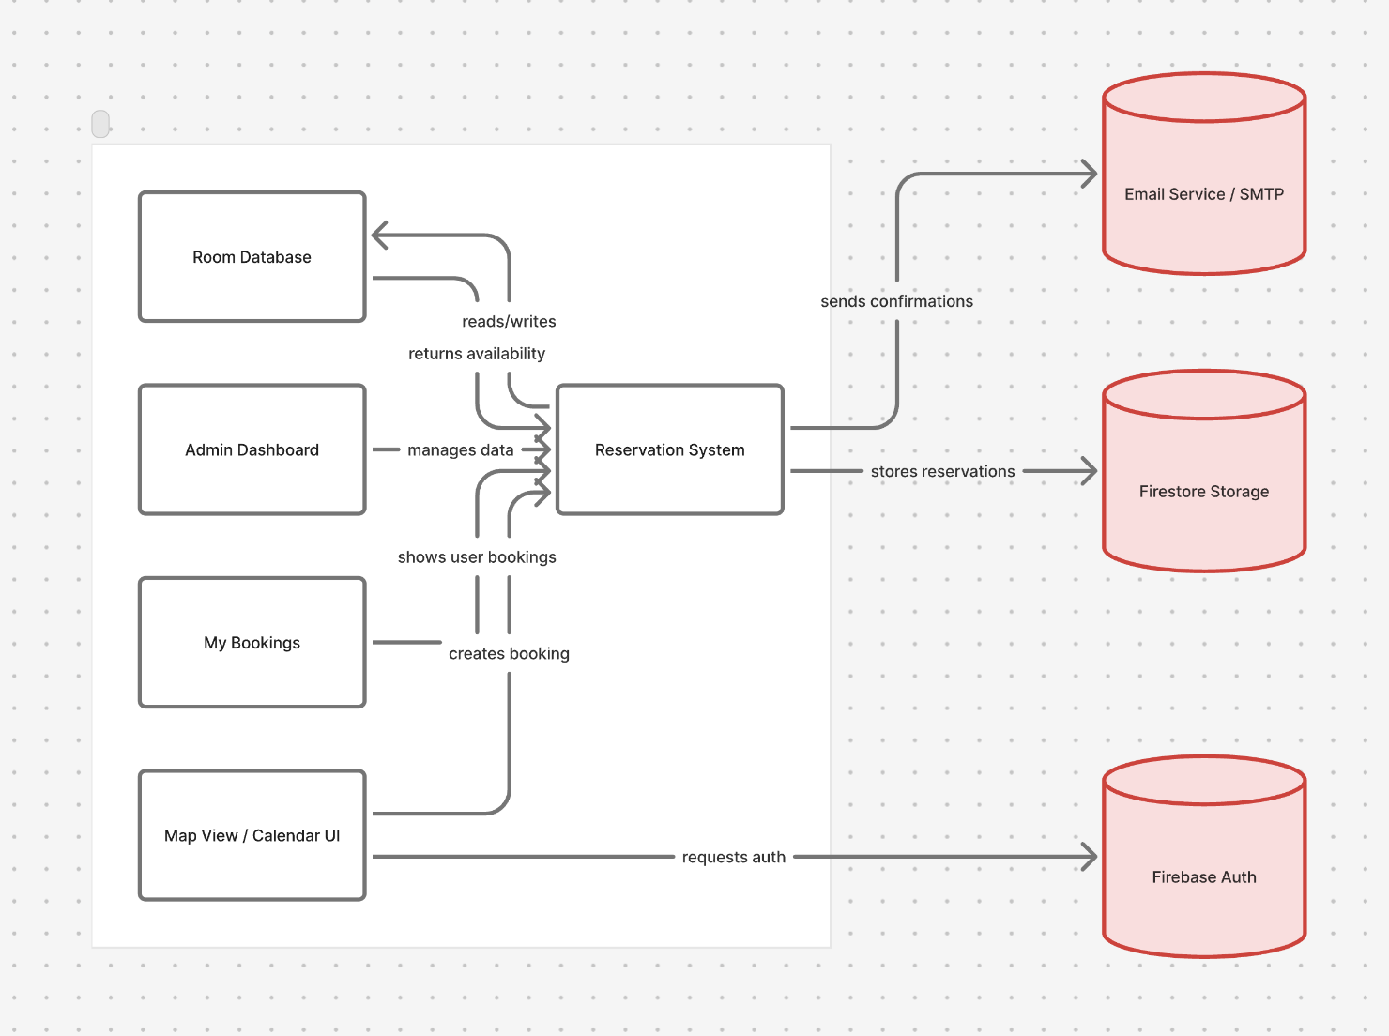

Figure 1: Simplified architecture

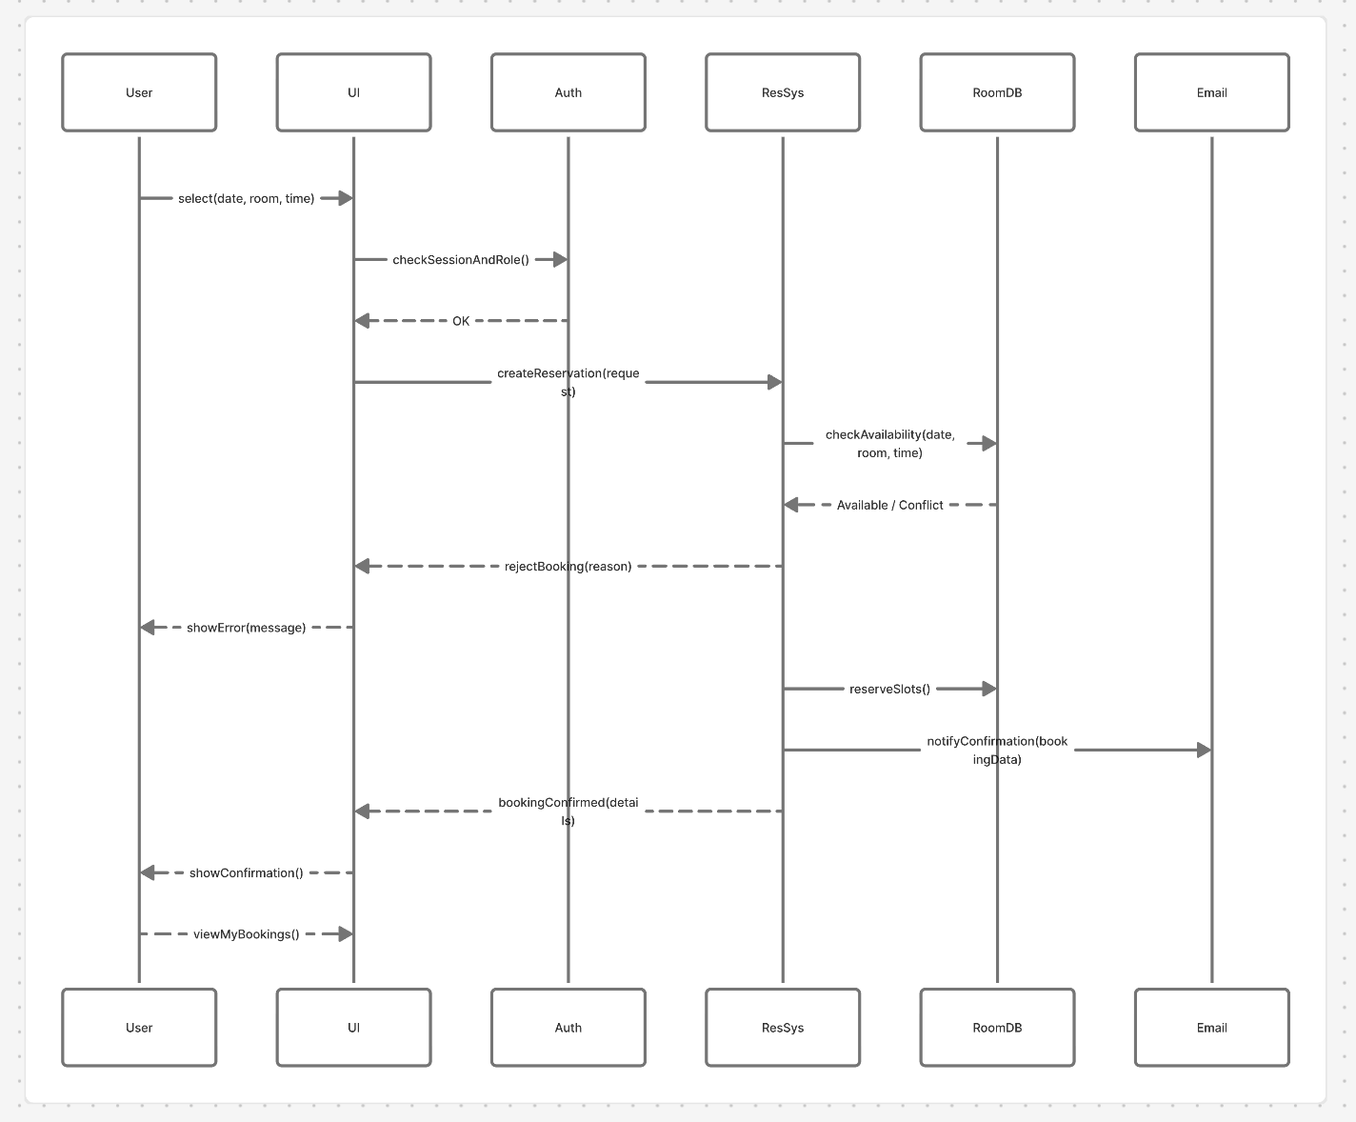
Figure 2: Simplified booking check.

Software Modules

Authentication & User Management

4.1.1 Primary Role and Function
This module handles user authentication, authorization, and identity management. It verifies users through potentially a Firebase Authentication (this may change due to conversations still ongoing with stakeholders), establishes secure sessions, and associates each account with one of three roles: Admin, Faculty, or Student. It ensures that other modules can reliably determine who is signed in and what actions each user is permitted to perform.

4.1.2 Interface
This module interacts with other system components to retrieve the current user identity, determine their role, and guard access to privileged operations. When a user logs in, their credentials are validated and associated with a role, which is then referenced by the Reservation System, My Bookings, and all user-facing interfaces.

4.1.3 Static Model
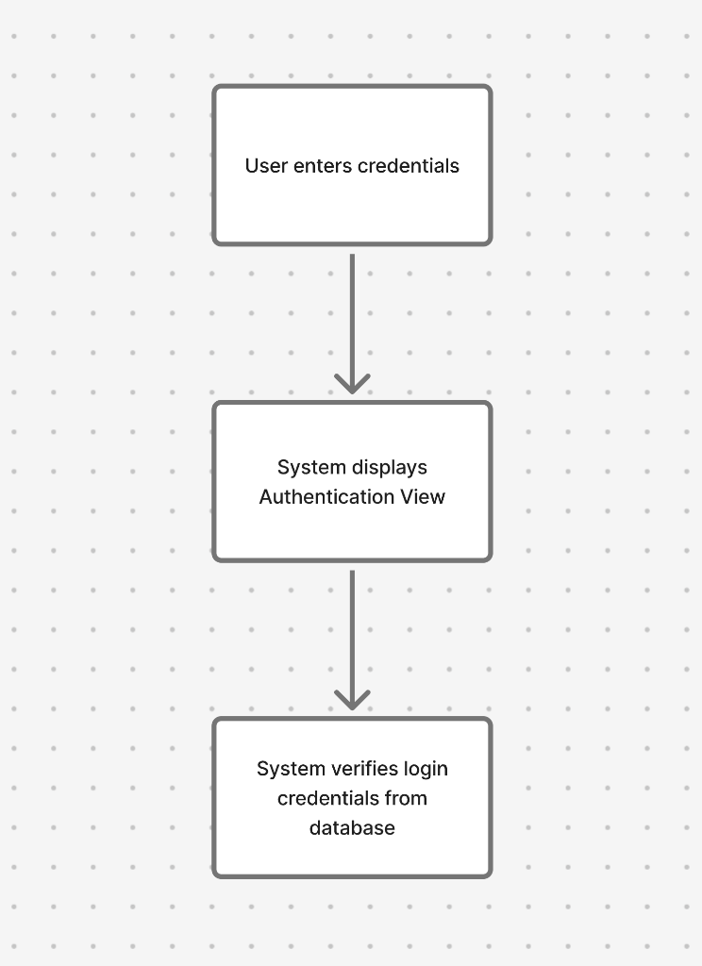

4.1.4 Dynamic Model
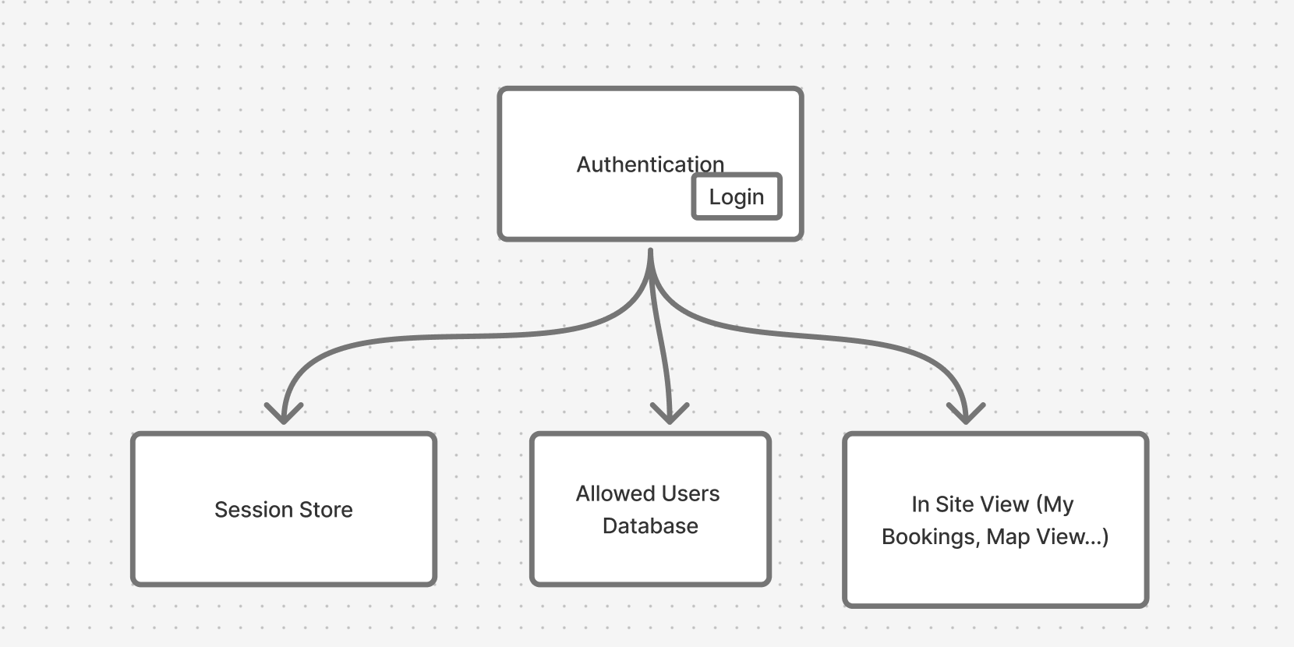
4.1.5 Design Rationale
Because the application requires strict control over who can view or modify system data, it was essential to centralize identity and role verification in one module. Using an authentication system (to be determined) allows the system to manage user credentials securely while simplifying integration across components. By consolidating login, role assignment, and access verification, the architecture avoids redundancy and reduces the risk of inconsistent permission handling. This structure also streamlines maintenance, since any change to role definitions or authentication rules automatically applies to all dependent modules.

Reservation System

4.2.1. Primary Role and Function
The Reservation System manages all scheduling and booking activity within the application. It handles the creation, updating, and cancellation of reservations while enforcing conflict detection to prevent overlapping bookings. This module supports both one-time and repeat reservations and coordinates directly with the Room Database for availability checks and with the Email Service for confirmations and updates. Acting as the system’s central scheduling service, it ensures that all bookings follow the same validation and approval rules.

4.2.2. Interface
When a user requests a reservation, the module verifies availability through the Room Database, records valid bookings, and triggers confirmation emails. Administrative actions such as approvals or cancellations are also processed through this same interface via the Admin Dashboard. Other components like the Map View, Calendar View, and My Bookings access the Reservation System to retrieve or modify reservations, ensuring synchronized data across all user interfaces.

4.2.3. Static Model
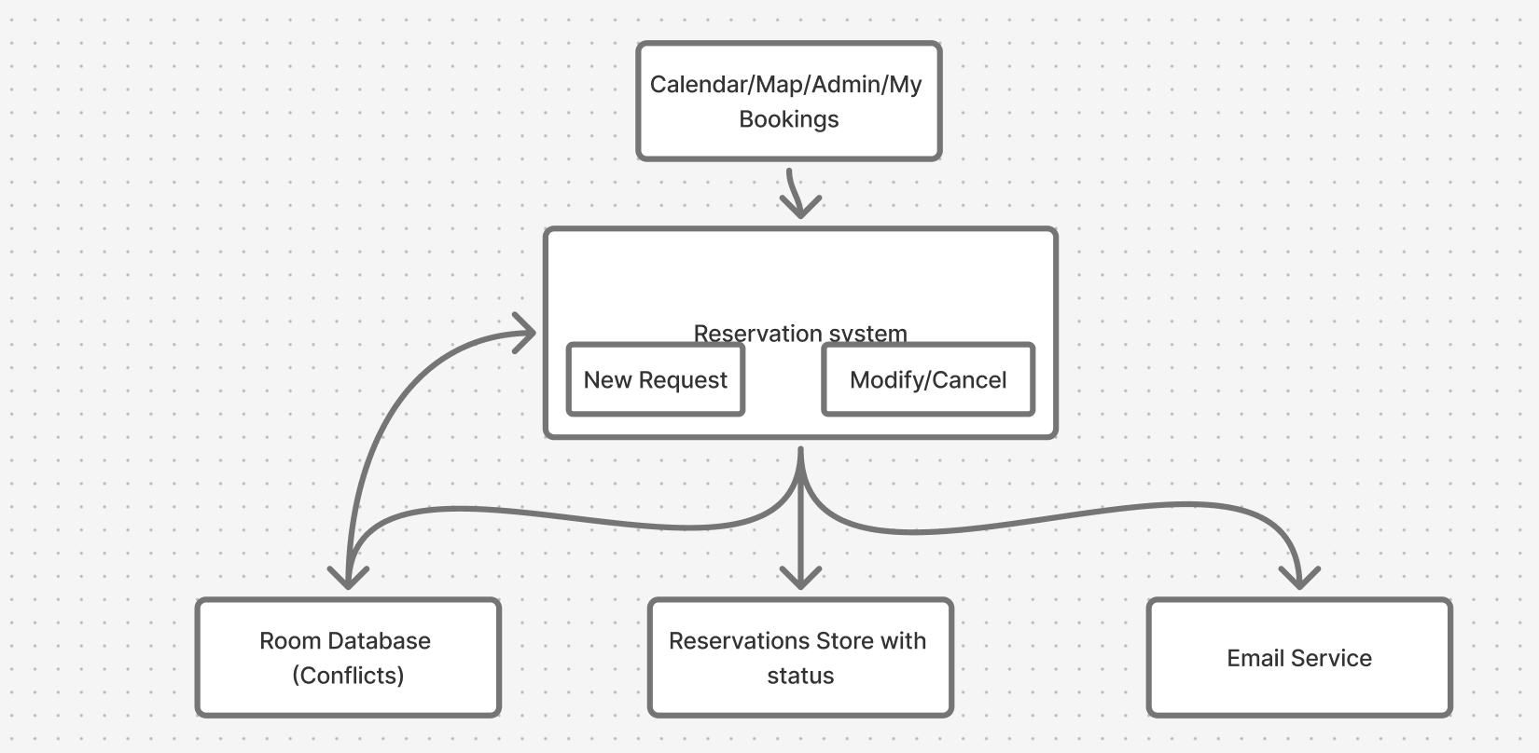
4.2.4 Dynamic model
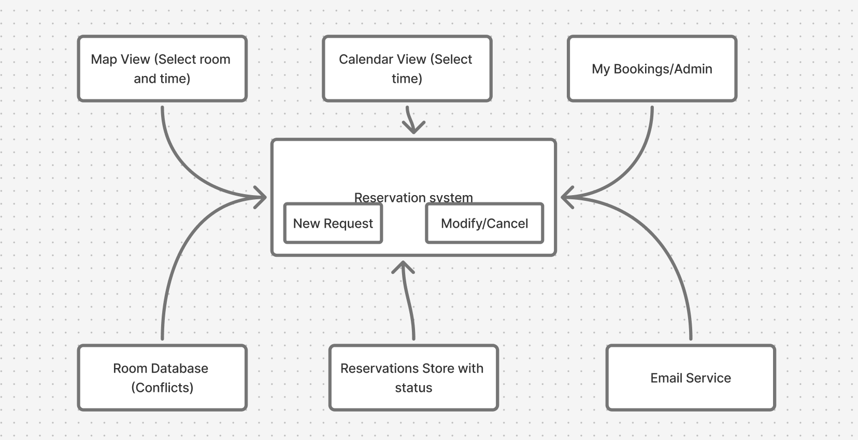
4.2.5 Design rationale
Centralizing reservation logic ensures consistent enforcement of policies and simplifies maintenance by isolating scheduling behavior from UI logic. It reduces redundancy and makes future changes to rules or validation processes easier to implement. The unified structure supports scalability for multiple concurrent users and flexible approval hierarchies.

Room Database
4.3.1. Module role and primary function
The Room Database module stores all authoritative information about Deschutes Hall rooms, including room names, capacities, locations, available equipment, and schedules. It provides query and update capabilities to both administrative and reservation components, ensuring all modules rely on a single source of truth.
4.3.2. Interface
It offers read and write functions to retrieve room attributes and update availability when reservations are made, modified, or canceled. The Reservation System queries it for real-time room status, while the Admin Dashboard uses it to update configurations and building hours.

4.3.3. Static model
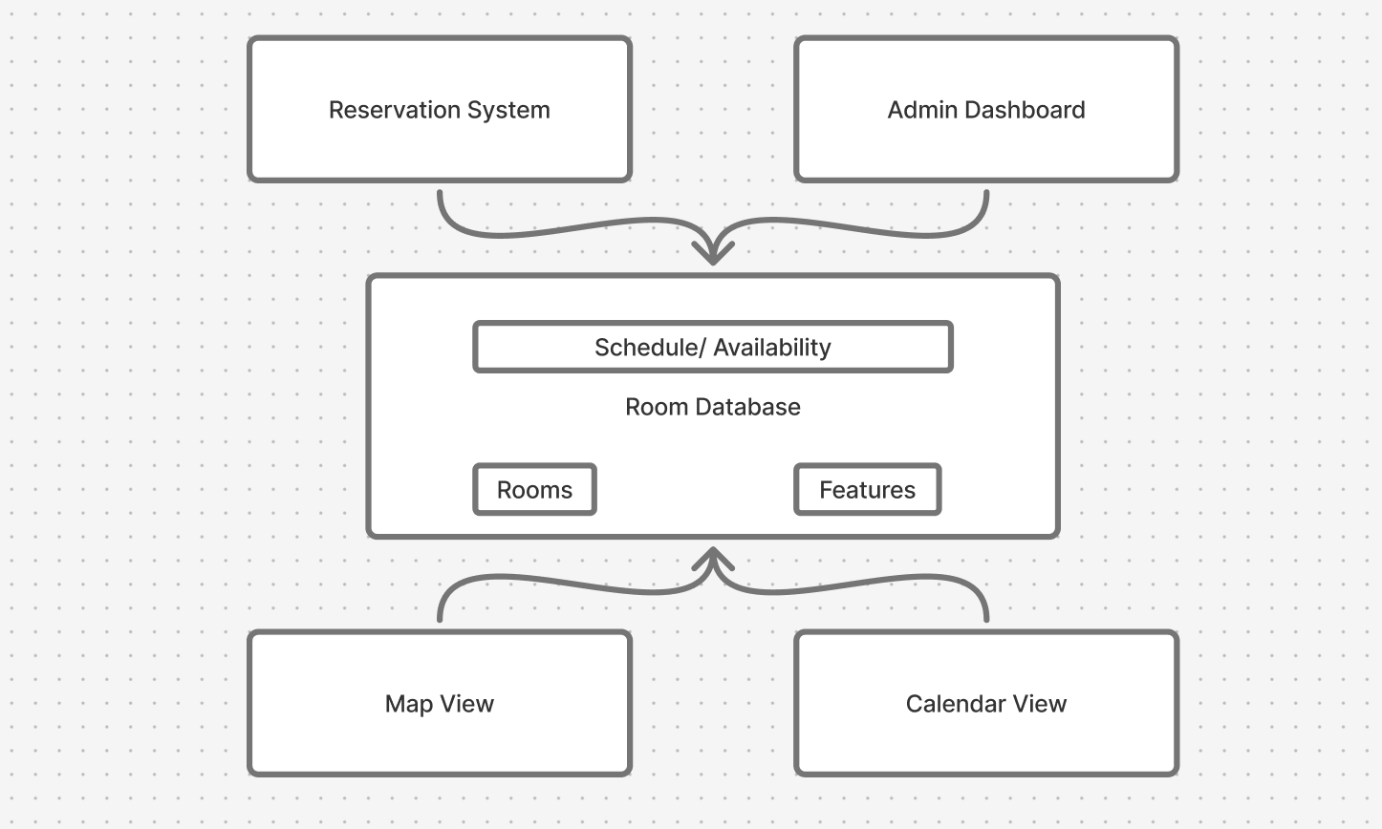

4.3.4. Dynamic model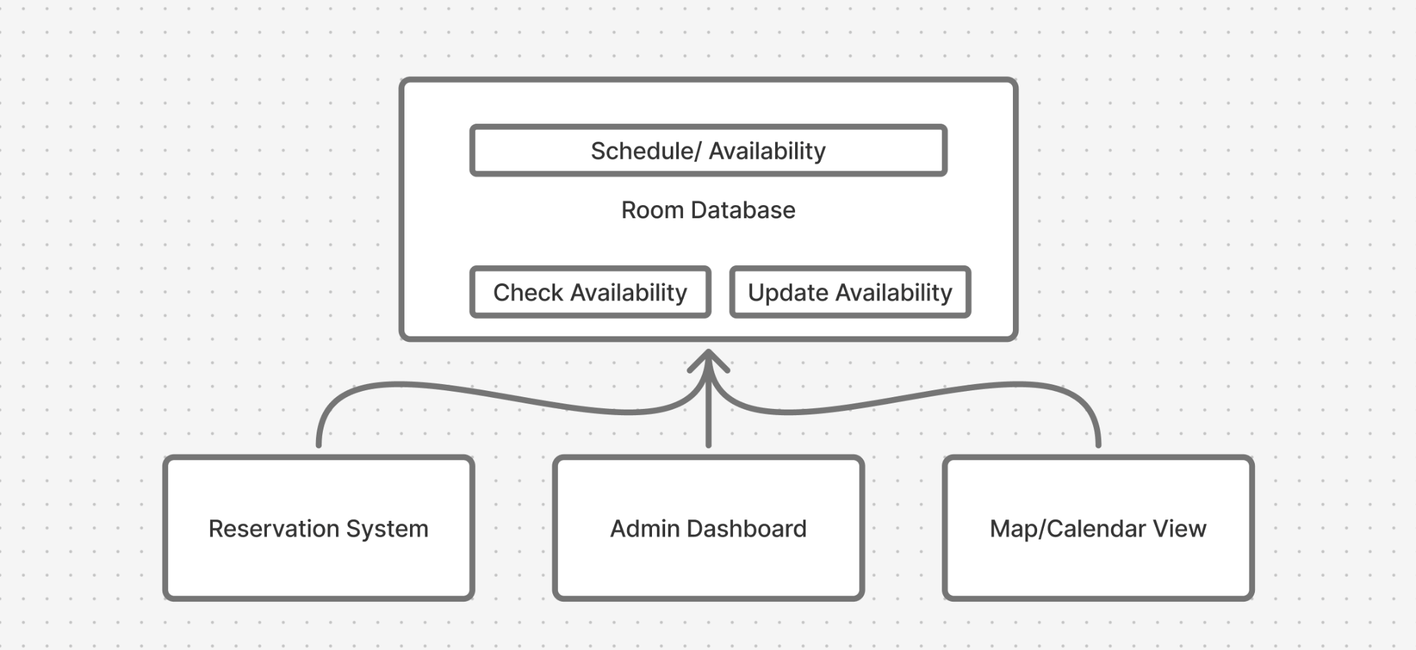

4.3.5. Design rationale
Maintaining room data independently from reservations provides flexibility and easier data management. It enables filtering by room features, bulk edits, and accurate data validation without duplicating room information across components.

Map View Interface
4.4.1 Module role and primary function.
Provides a building map where users click rooms to start bookings; indicates availability by highlighting available rooms for a selected date.
4.4.2. Interface to other modules.
It communicates primarily with the Reservation System for creating reservations and the Authentication & User Management module to ensure that the logged-in user has appropriate access. It also retrieves room data from the Room Database to update the visual map dynamically.

4.4.3.Static model.
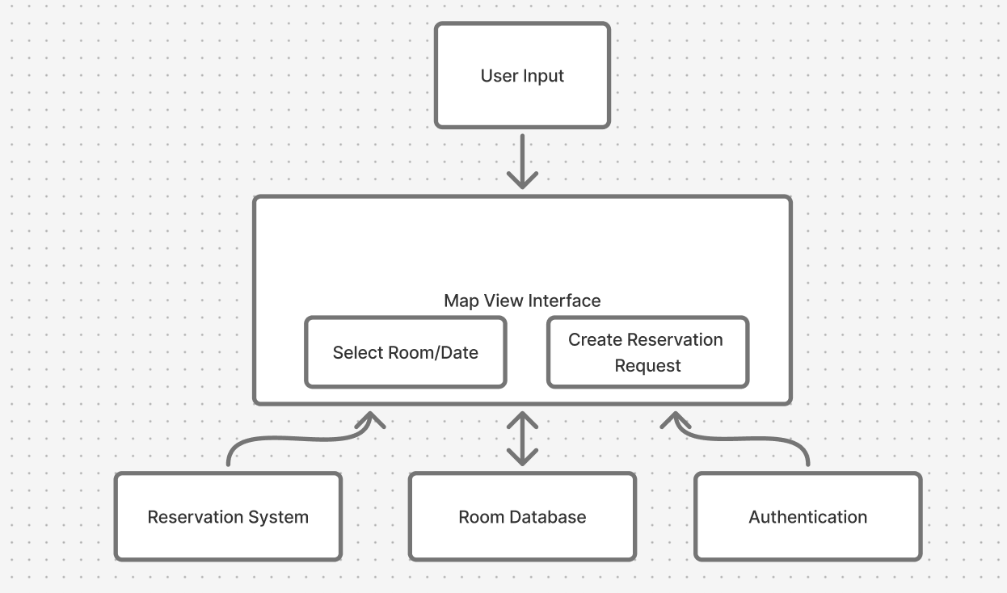
4.4.4. Dynamic model.
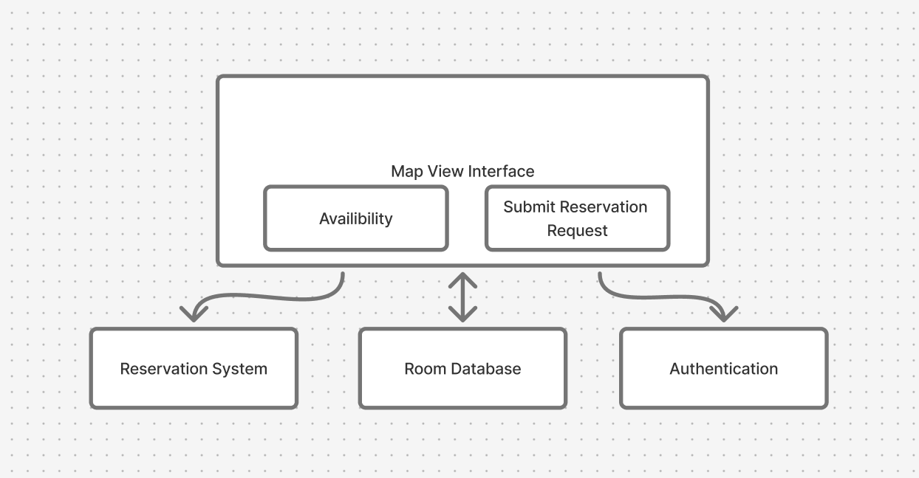
4.4.5. Design rationale.
By visualizing room availability, the map view enhances usability and resolves the prior issue of users needing to cross-reference text lists. Its modular structure allows visual updates and map data changes without affecting backend functionality.

Calendar View
4.5.1. Module role and primary function.
The Calendar View presents a timeline-based interface that displays room availability across days and weeks. It allows users to select time slots directly and submit reservation requests while reviewing conflicts in real time.
4.5.2. Interface to other modules.
It sends and receives data from the Reservation System to display available time blocks, retrieves room information from the Room Database, and checks user roles via Authentication & User Management.
4.5.3. Static model.
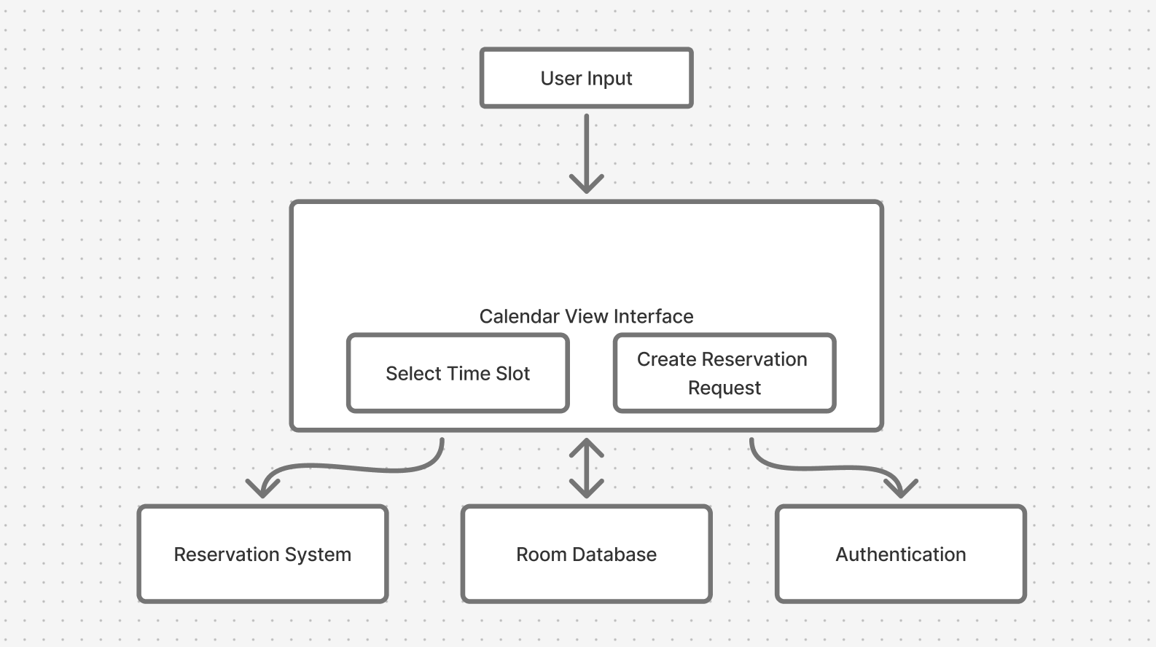
4.5.4. Dynamic model.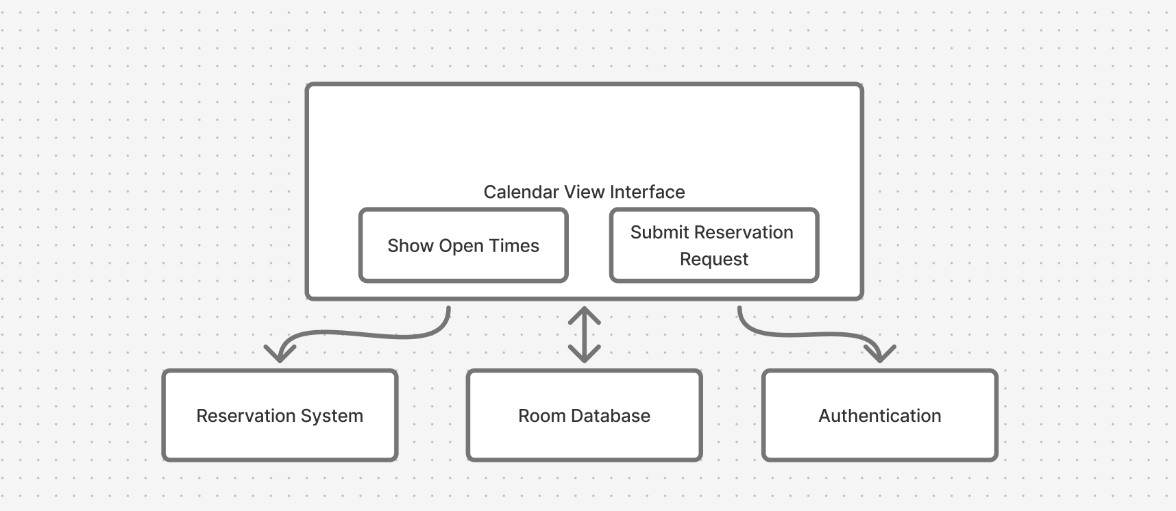
4.5.5. Design rationale.
Providing a familiar calendar-based interface helps accommodate users accustomed to traditional scheduling tools. It improves accessibility, reduces cognitive load, and allows rapid comparison of room availability across multiple dates.

My Bookings Interface
4.6.1. Module role and primary function.
This module serves as a personalized dashboard that displays all active, pending, and past reservations. Users can modify or cancel existing bookings directly through this interface, promoting a self-service experience that reduces administrative workload.
4.6.2. Interface to other modules.
It retrieves user-specific data from the Reservation System, validates user identity through Authentication & User Management, and sends any update or cancellation actions back to the Reservation System. Notifications for changes are then handled by the Email Service.
4.6.3. Static model.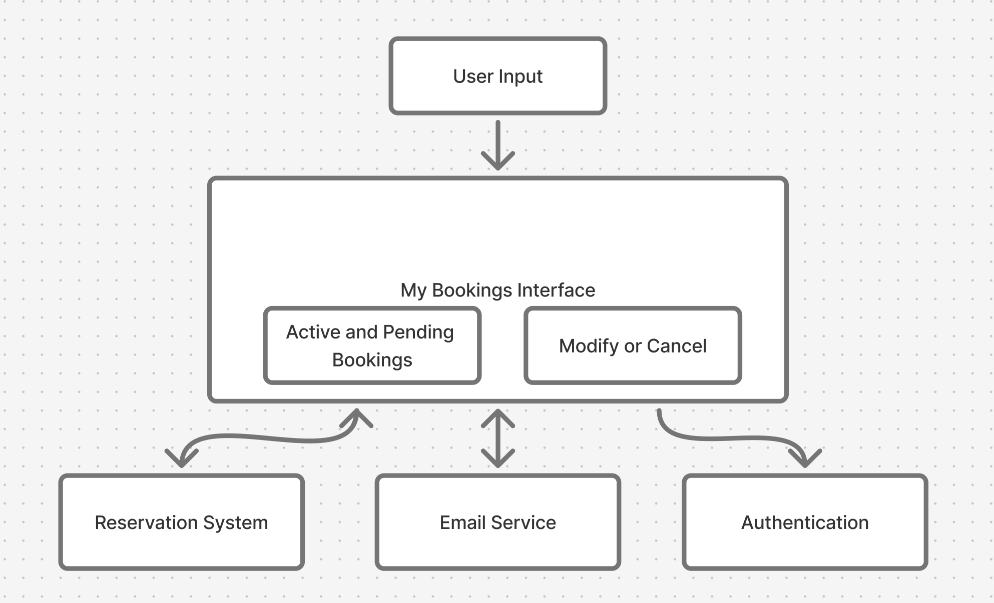4.6.4. Dynamic model.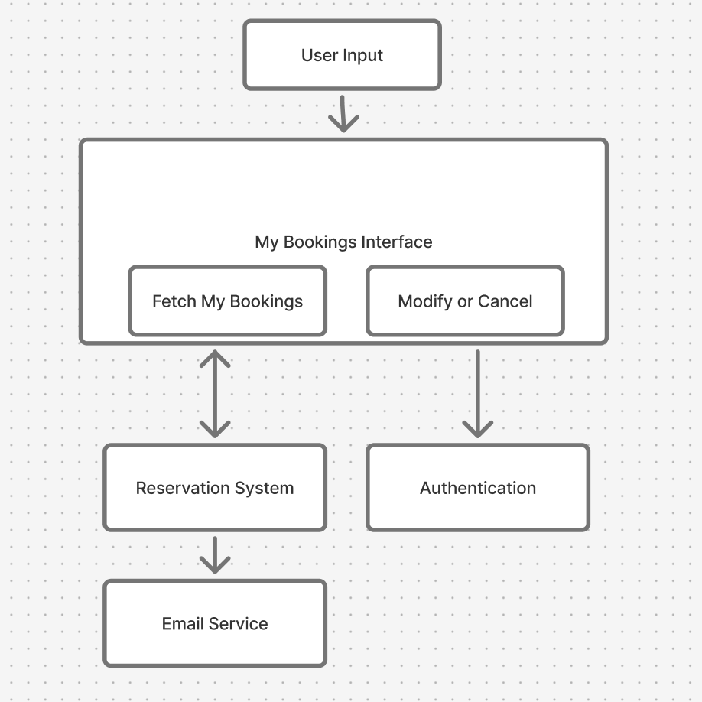

4.6.5. Design rationale.
Helps users self-manage reservations, eliminating repetitive communication with administrators. The design simplifies workflows, maintains transparency, and supports real-time updates through seamless module communication.

Admin Dashboard
4.7.1. Module role and primary function.
The Admin Dashboard provides privileged users with the ability to configure building policies, manage rooms, and approve or deny booking requests. It consolidates all administrative tools in a single interface to ensure consistent policy enforcement across the system.

4.7.2. Interface to other modules.
It interacts with the Reservation System to update booking statuses, the Room Database to modify room details, and the Email Service to send decision notifications. Authentication & User Management ensures only authorized administrators access these features.

4.7.3. Static model.
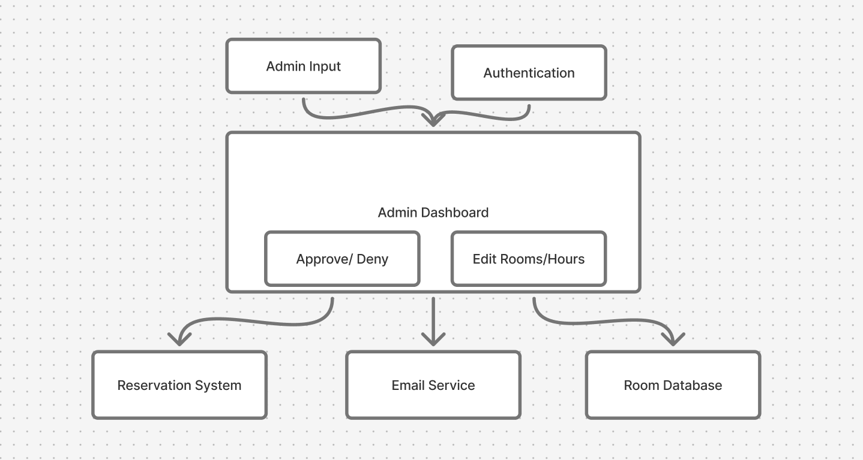

4.7.4. Dynamic model.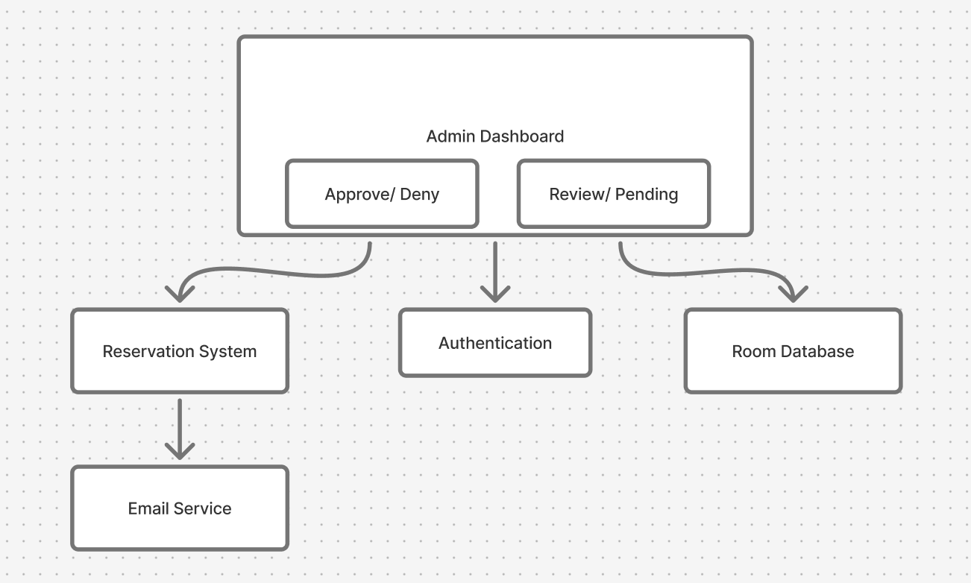

4.7.5. Design rationale.
Centralizing administrative controls provides transparency and eliminates redundant manual processes. It establishes a structured governance system while maintaining data integrity and clear role boundaries.

Email Service / Firebase Integration
4.8.1. Module role and primary function.
The Email Service is responsible for sending all automated notifications, including reservation confirmations, cancellations, approvals, and reminders. Integrated with Firebase, it ensures reliable message delivery and synchronization with user actions across the platform.
4.8.2. Interface to other modules.
It receives triggers from the Reservation System whenever a booking is created, updated, or removed, and uses user data from Authentication & User Management to address messages appropriately. It also communicates confirmation status updates to My Bookings and Admin Dashboard modules.
4.8.3. Static model.
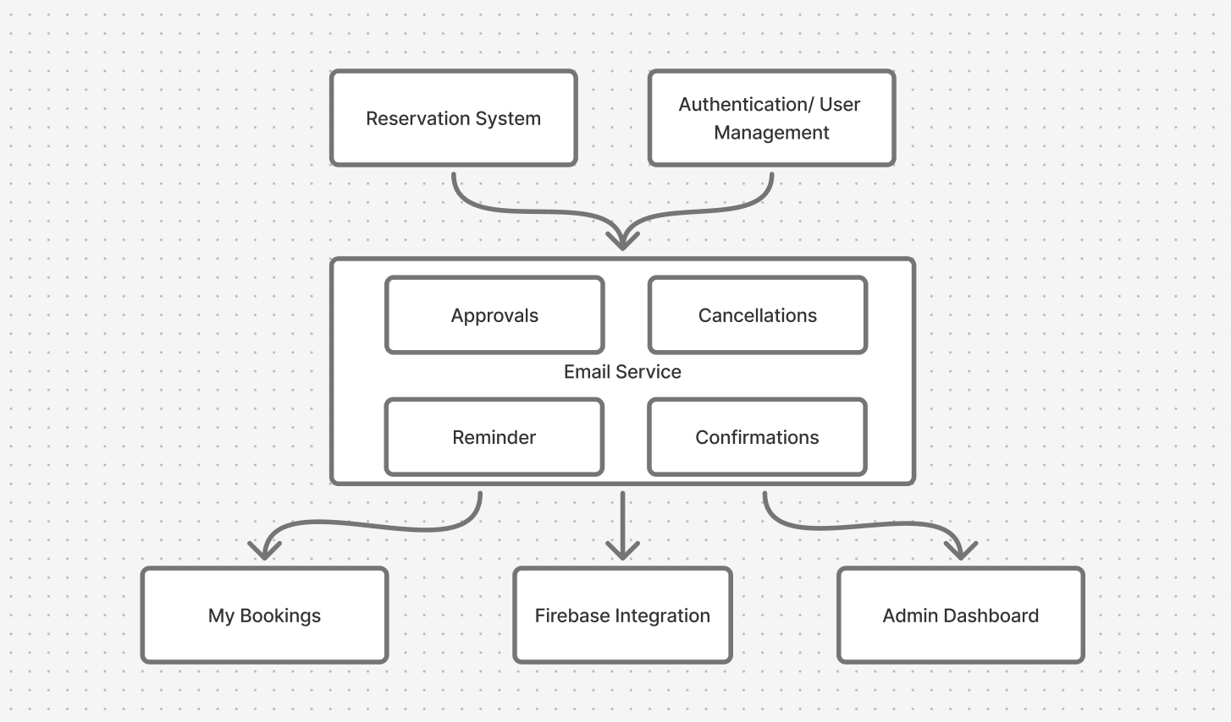

4.8.4. Dynamic model.
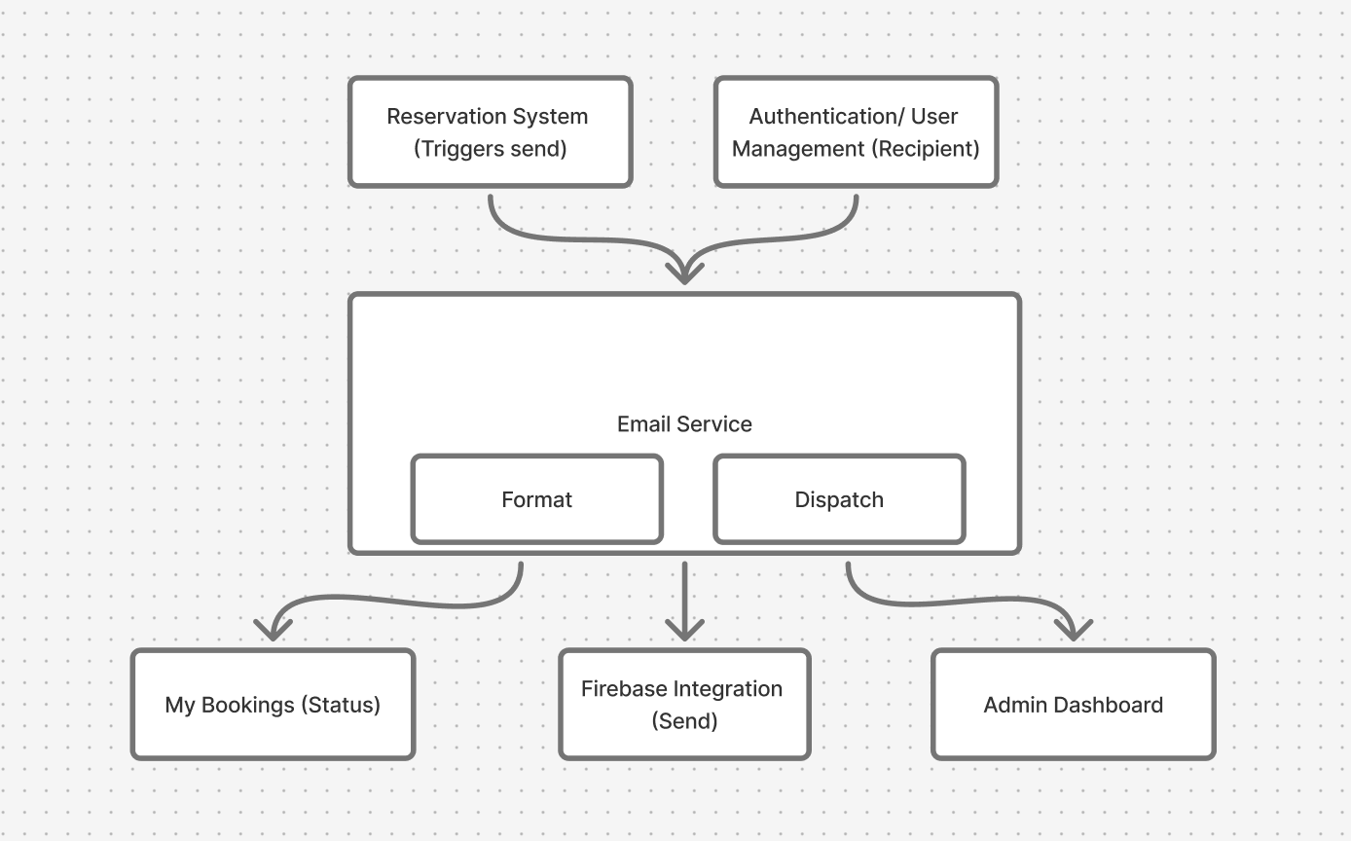
4.8.5. Design rationale.
Automated notifications enhance reliability and accountability. Integrating with Firebase ensures consistent delivery and unified user experience across all modules. This design prevents missed communications and simplifies error handling by routing all notifications through one service layer.

Dynamic Models of Operational Scenarios (Use Cases)

Use Case: Approve or Deny a Reservation
• Admin sees there is a new booking in “Bookings to Approve” card on Admin Tools page
• Admin reviews details listed in request
• Admin may approve or deny the request
• The Reservation System updates reservation status and logs the decision
• The Email Service sends a notification to the requester
• My Bookings updates the displayed status for the user
Use Case: Modify an Existing Reservation
• User navigates to My Bookings
• Selects a reservation and chooses “Modify”
• Fields are made editable (recurrence, purpose, name, time,)
• User submits changes
• Reservation system searches for conflicts if date/time was modified
• If valid, updates reservation
Use Case: Cancel a Reservation
• User navigates to My Bookings
• Selects a reservation and chooses “Cancel”
• System asks user to verify cancellation
• If user confirms, reservation is cleared from the system
Use Case: View my Bookings
• User navigates to My Bookings
• Each booking is displayed in a vertical list as a widget
• List may be scrolled through by user to see all bookings
• Detailed information about each booking will be displayed along with Modify and Cancel buttons when the widget is clicked
Use Case: Manage Rooms and Building Hours
• Admin navigates to Manage Building
• Selects a room to modify, or is able to set general hours
• Updates attributes
• Changes are stored in database
• If there are conflicts, alerts will be sent to those who had bookings
Use Case: System-Triggered Email Notifications
• An action will trigger the email notification
- Student requests a reservation, admin cancels or modifies a user’s reservation, confirmation after a booking is made
• Email Service formats and sends message
- Booking info, confirm/deny if the email contains a request, link to website
Use Case: Create a Reservation (Student with Approval)
• Students sign in and select a room/date via Map or Calendar view.
• The system verifies identity and role (Student).
• Student submits reservation request; Reservation System checks conflicts and policies.
• If there is no conflict, the reservation is created with status=Pending; Admin is notified.
• Admin approves/denies; user is notified via email; My Bookings reflects status.

References

GeeksforGeeks. Static and Dynamic Models in Software Engineering.
Retrieved from https://www.geeksforgeeks.org/software-engineering/static-and-dynamic-models-in-software-engineering/
Firebase Documentation. Retrieved from https://firebase.google.com/docs
Pallets Projects. Flask Documentation (Version 3.x). Retrieved from https://flask.palletsprojects.com/
Bootstrap Team. Bootstrap 5 Documentation. Retrieved from https://getbootstrap.com/docs/5.0/getting-started/introduction/

- Acknowledgements

The SDS template was provided by Juan Flores, who changed the original document created by
Anthony Hornof.

