Deschutes Hall Room Reservation System
Software Requirements Specification
Esmé Nadeau, Kate Spencer, Katie Trinh, Lily Spurgat
https://github.com/esme-nadeau/422-Price-Girls
Professor Juan Flores
October 26, 2025
Table of Contents
1. SRS Revision History 2
2. The Concept of Operations (ConOps) 2
2.1.Current System or Situation 2
2.2. Justification for a New System 3
2.3. Operational Features of the Proposed System 4
2.4. User Classes 6
2.5. Modes of Operation 7
2.6. Operational Scenarios (Use Cases) 8
3. Specific Requirements 10
3.1 External Interfaces (Inputs/Outputs) 10
3.2 Functions 11
3.3 Usability Requirements 11
3.4. Performance Requirements 12
3.5 Software System Attributes 12
4. References 12
5. Acknowledgments 12

SRS Revision History
Date | Author | Description
10-06-2025 | Katie Trinh | Uploaded initial document to the shared drive
10-12-2025 | Katie Trinh | Completed formatting, and finished up to section 2.0
10-15-2025 | Katie Trinh | Finished sections 2.1-2.6
10-16-2025 | Katie Trinh | Finished sections 3.1-5.0
10-17-2025 | Kate Spencer | Reviewed document, made minor changes.
10-26-2025 | Katie Trinh | Final revisions for submission of final draft including changes after meeting with stakeholders.

Concept of Operations (ConOps)
The Concept of Operations (ConOps) describes the characteristics of a proposed system from the users’ perspective. According to IEEE Std 1362-1998, it “is used to communicate overall quantitative and qualitative system characteristics to the user, buyer, developer, and other organizational elements (for example, training, facilities, staffing, and maintenance).” The ConOps essentially communicates the overall system to all stakeholders.

2.1. Current System or Situation
The current system used by Deschutes for managing room reservations is a web-based platform designed for the University of Oregon’s Computer Science department. The website consists of two main components: a weekly calendar page and a room reservation form. The weekly calendar page displays all existing reservations and available time slots with color-coding to differentiate rooms. The room reservation form, which is accessed through the “Reserve Room” button at the bottom of the calendar page, lets a user create a reservation. To create a reservation, a user must first review the calendar for open time slots and rooms, then navigate to the reservation form to enter information such as the room number, date, time, and purpose. Because these two interfaces are separate, users must manually recall the details of available times and spaces when completing the form.

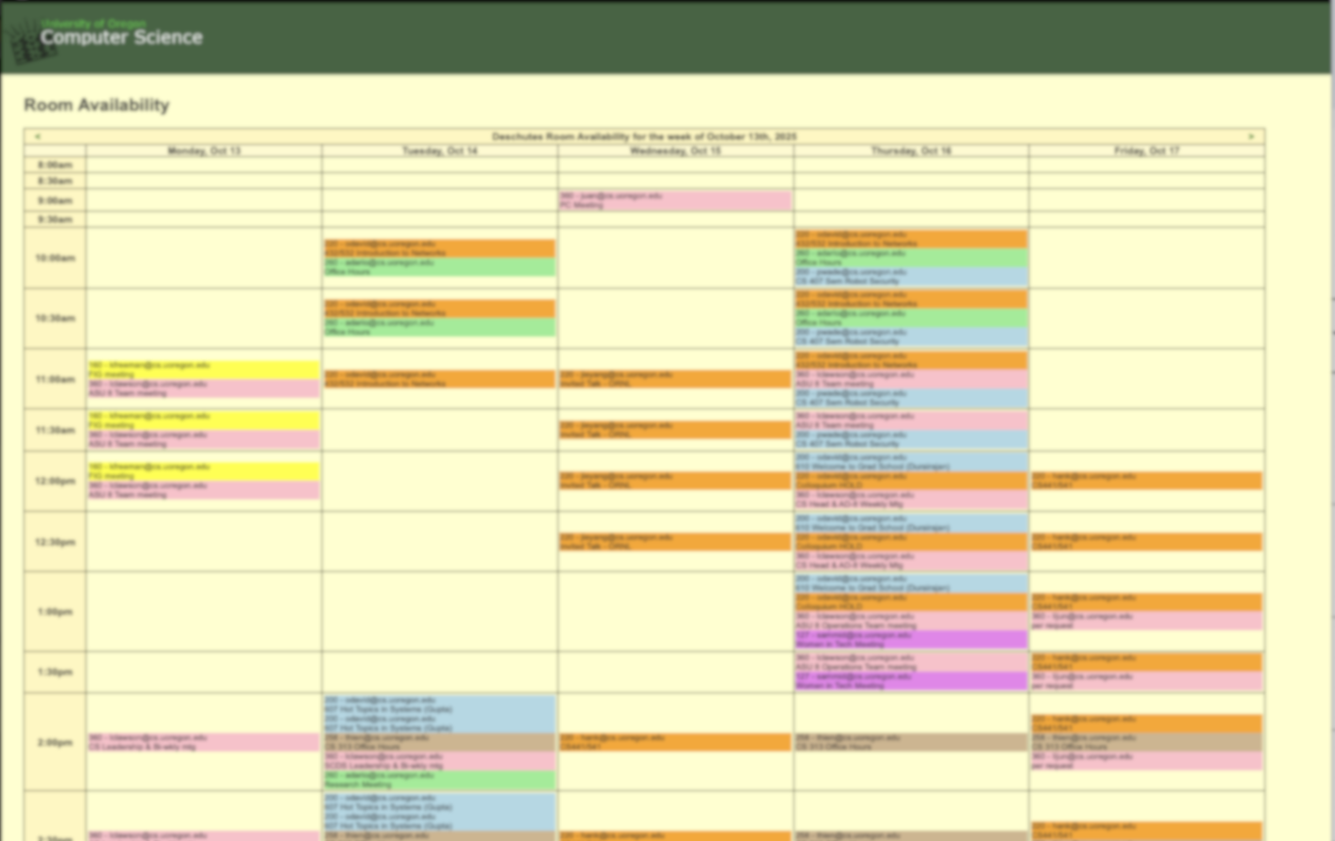
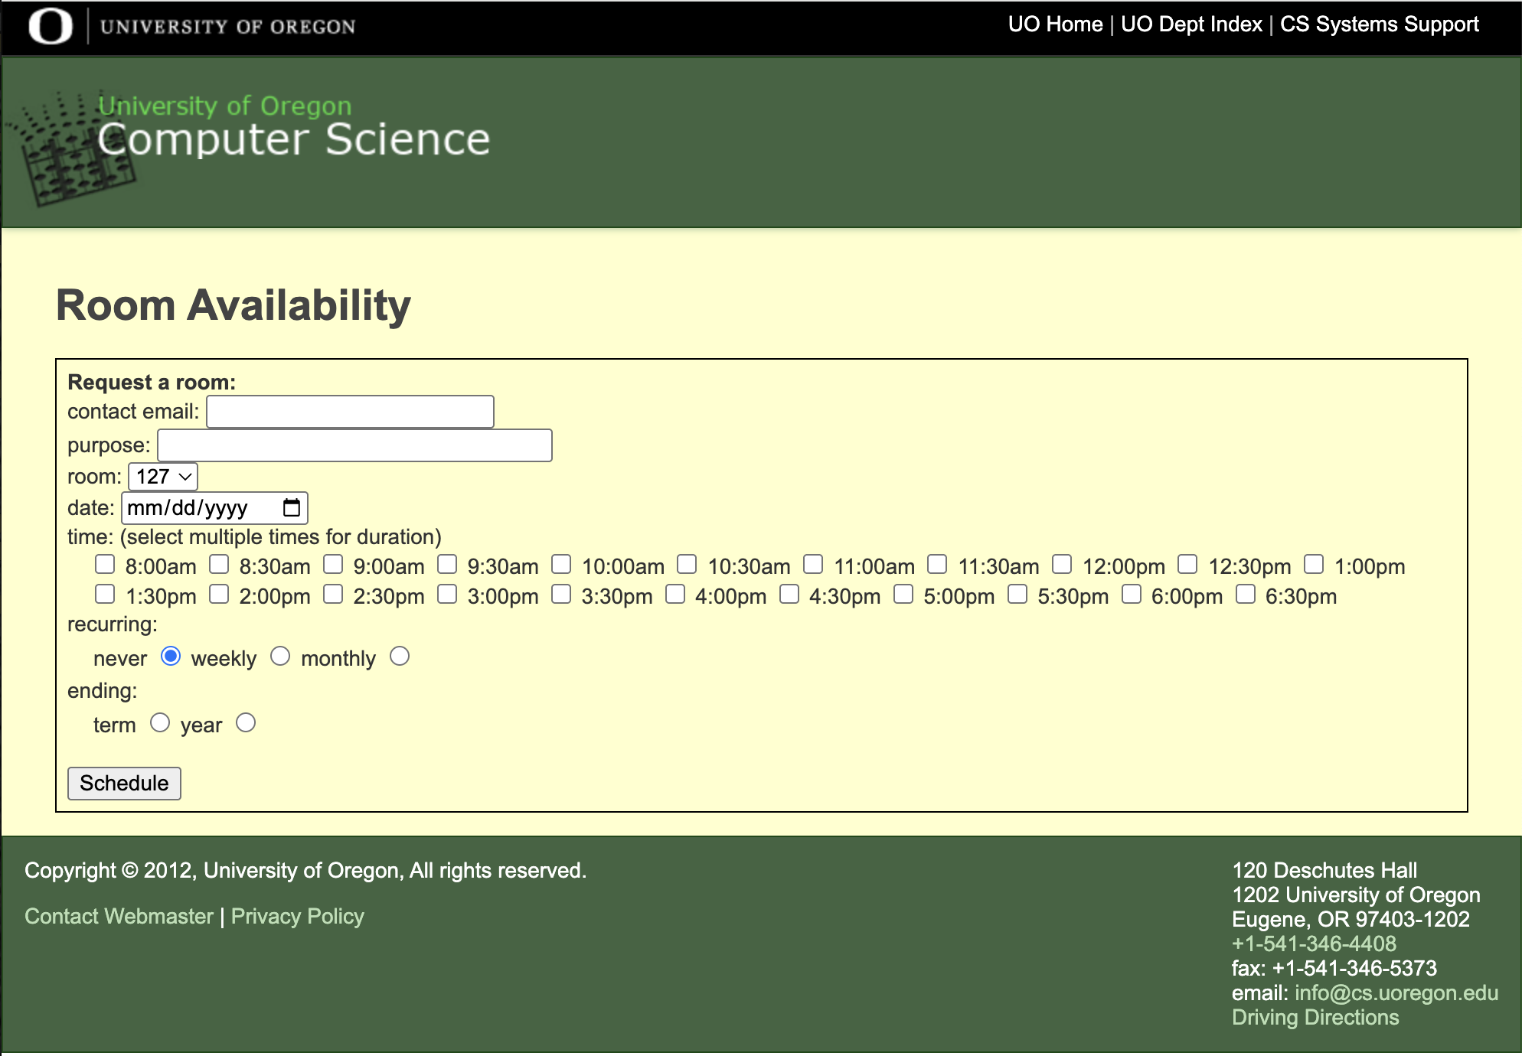
Figure 1. Current Scheduling System Site

Once a reservation is scheduled, the system automatically sends a confirmation email from apache@cs.uoregon.edu. This automated email lists the reserved room, date and time of when the reservation starts, and reason for the reservation. After this confirmation, the reservation appears on the calendar. Users who need to cancel or modify a reservation must contact the administrator directly, as the interface provides no self-service modification or deletion options.

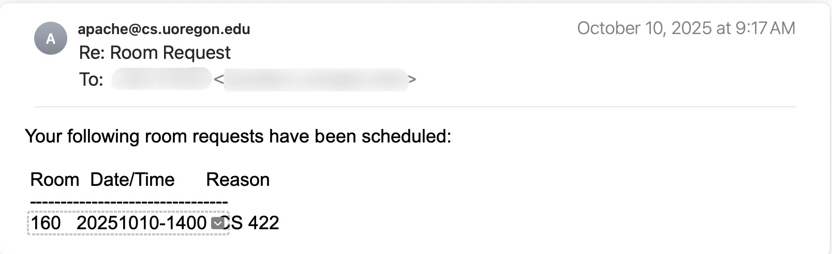
Figure 2. Current Confirmation Email

2.2. Justification for a New System
Although the existing Deschutes room reservation system performs its intended function at a basic level, its current implementation presents several shortcomings that limit its efficiency and accessibility.

The most immediately obvious issue is the system’s unintuitive interface. It requires users to manually cross-reference available time slots on the calendar with the separate reservation form. Additionally, it lacks visual indicators for room details like capacity, equipment, or where the room is located in the building.
One of the other significant issues is the inability for users to modify reservations. Once a request has been approved, users cannot directly edit or delete it through the interface. Any updates or cancellations must be requested manually via an email to the systems administrator, increasing administrative workload and delaying scheduling changes.
The confirmation email that is sent after a booking is made presents another area for improvement. It includes only basic information such as the room number, date and time, and purpose as seen in Figure 2. It is missing key details that could be helpful to the user, such as duration of the reservation, capacity of the space, and available resources in the reserved room.
Another issue is the system’s lack of effective conflict-handling. When a user tries to create a booking, and an overlap exists with a previously made booking, an error message is displayed. However, this error message gives no detail on what the overlap is. Even more concerning is after this error is displayed, the user is still allowed to proceed by submitting the reservation request a second time, resulting in overlapped bookings.
Furthermore, there is no mechanism for maintaining accurate room data. For example, Deschutes 100 is now designated for the Teaching Security Operations Center (TSOC). Despite this, Deschutes 100 still appears as a reservable space on the room reservation form.
To justify the need for a new system, we will examine the gap between the number of users of the current system and the potential number of individuals that could benefit from having a better scheduling system. Currently, no more than 50 users (including faculty, the ASU8 team, and a small number of students) actively use the existing platform. However, according to University of Oregon data from their official site, there are 650 undergraduate Computer Science majors, not including graduate students, faculty, and staff who regularly use Deschutes Hall. This suggests that a redesigned and more accessible system could serve over 700 users, expanding its reach to nearly 10 times the current user base.

2.3. Operational Features of the Proposed System
The new Deschutes Room Reservation System will be a web-based platform designed to improve room booking and management for administrators, faculty, and students.

The backend is a Python/Flask application that handles HTTP requests, authorization, and business logic, and persists all data in Google Firebase’s Cloud Firestore. The frontend is implemented using Flask-rendered HTML templates with Bootstrap-styled CSS and JavaScript served from the Flask static directory.

Users will be able to view, book, and manage room reservations through two primary interfaces:
- Map View: An interactive SVG map of Deschutes Hall with three floors that allows users to visually explore and select available rooms. Clicking on a room displays details such as capacity, available equipment, and a photo.
- Calendar View: A time-based interface that lists bookings by date and time inspired by the old system, allowing users to compare availability across rooms and weeks. Clicking on a room from the dropdown menu also displays additional information such as capacity, available equipment, and a photo like the map view.

After selecting a room, users will complete a booking form through a reservation widget that requires details such as date, start and end time, duration, purpose, and recurrence settings. The system will automatically check for conflicts, preventing overlapping bookings and suggesting alternate times when necessary.

Upon successful completion of the booking form, students will receive a confirmation email that their request has been successfully made and is pending admin approval meanwhile faculty and admin bookings will automatically be approved. Subsequent modifications or cancellations trigger automatic email notifications and database updates.

The system also includes an “All Bookings” page. This is the default page when you first navigate to the site that provides a comprehensive view of every reservation in the building in a calendar format. There is varying level of information and interactivity that a user has with the “All Bookings” page depending on if they are not logged in, logged in as student, logged in as faculty, or logged in as admin.

The last page all logged in and authenticated users have access to is the “My Bookings” page where you can view all your personal bookings, modify, and/or delete a booking.

Administrators will also have access to an admin dashboard called “Admin Tools” where there are numerous tools for administrators to use. They have the ability to see and modify all bookings, create full building closures (ex. closing Deschutes for Thanksgiving break so no users can create bookings on those dates), add and manage users, add manage rooms, and clear the database of bookings older than 30 days. They can also modify and delete other people’s bookings through the “All Bookings” page if that is easier for the admin to view the same information.

It is unsure yet how authentication will be handled, but as of now we plan for it to be handled through Firebase Authentication, with the potential goal of integrating UO’s Shibboleth system in later iterations to support secure university-wide login using UO credentials. Users will have different access levels of administrator, faculty, or student each with tailored permissions and visibility based on their role. This is incredibly dependent on how conversations go with stakeholders.

Overall, the new Deschutes Room Reservation System emphasizes real-time interactions and updates, an intuitive user interface, secure access, and automated communication, addressing the key issues of the previous platform that we were able to identify and that faculty provided input on while aligning with the department’s updated technical and operational requirements.

Below are mockups illustrating the features and interface we plan to implement.
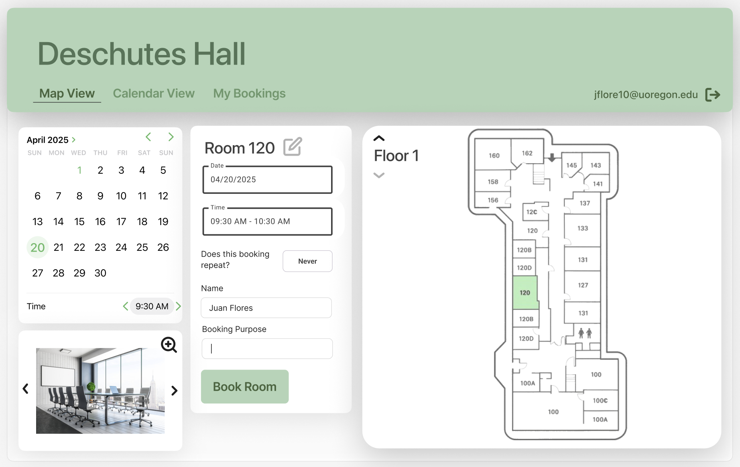
Figure 3. Map View
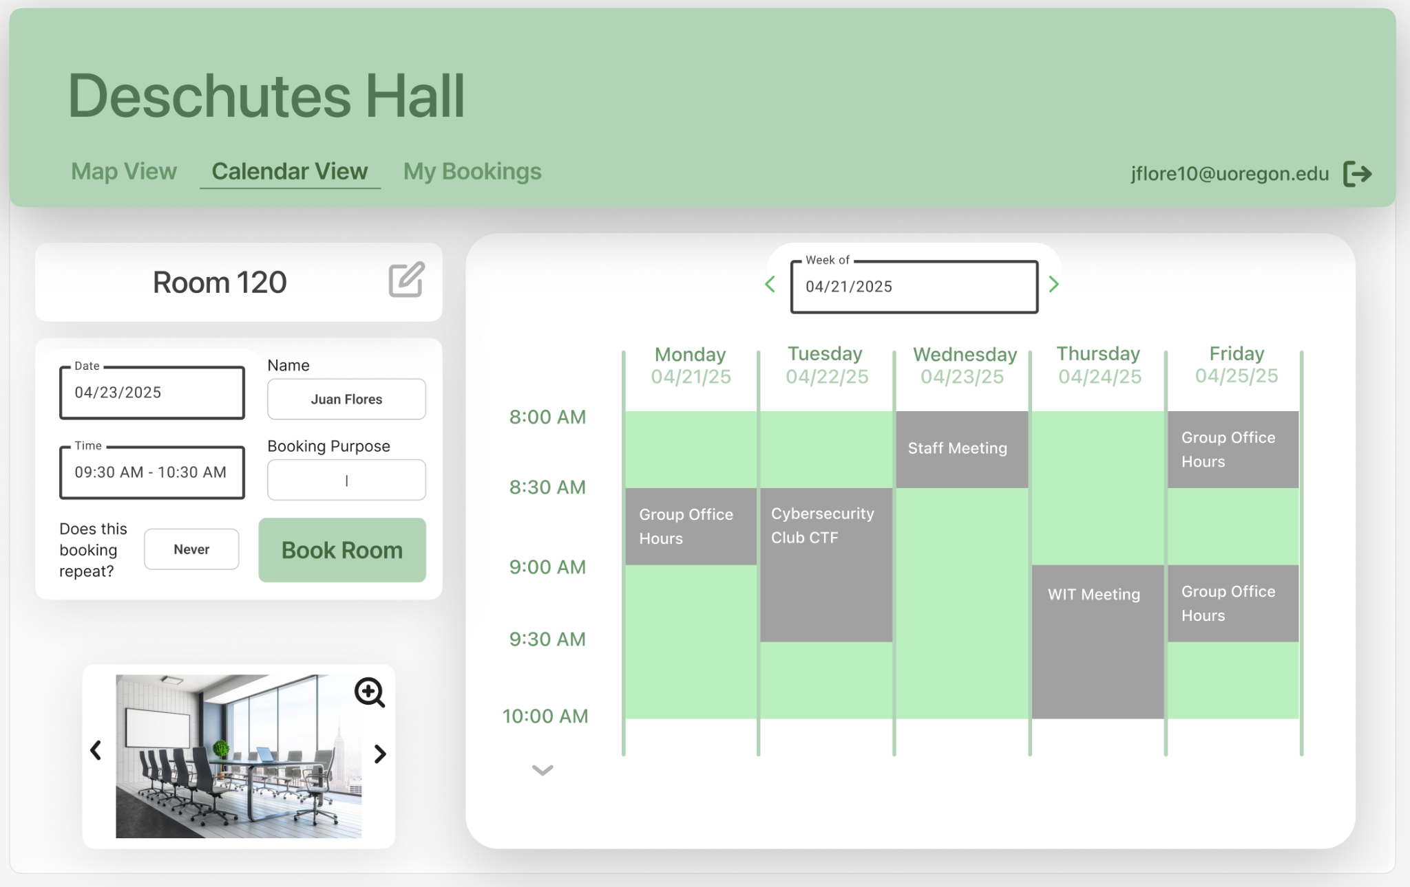
Figure 4. Calendar View
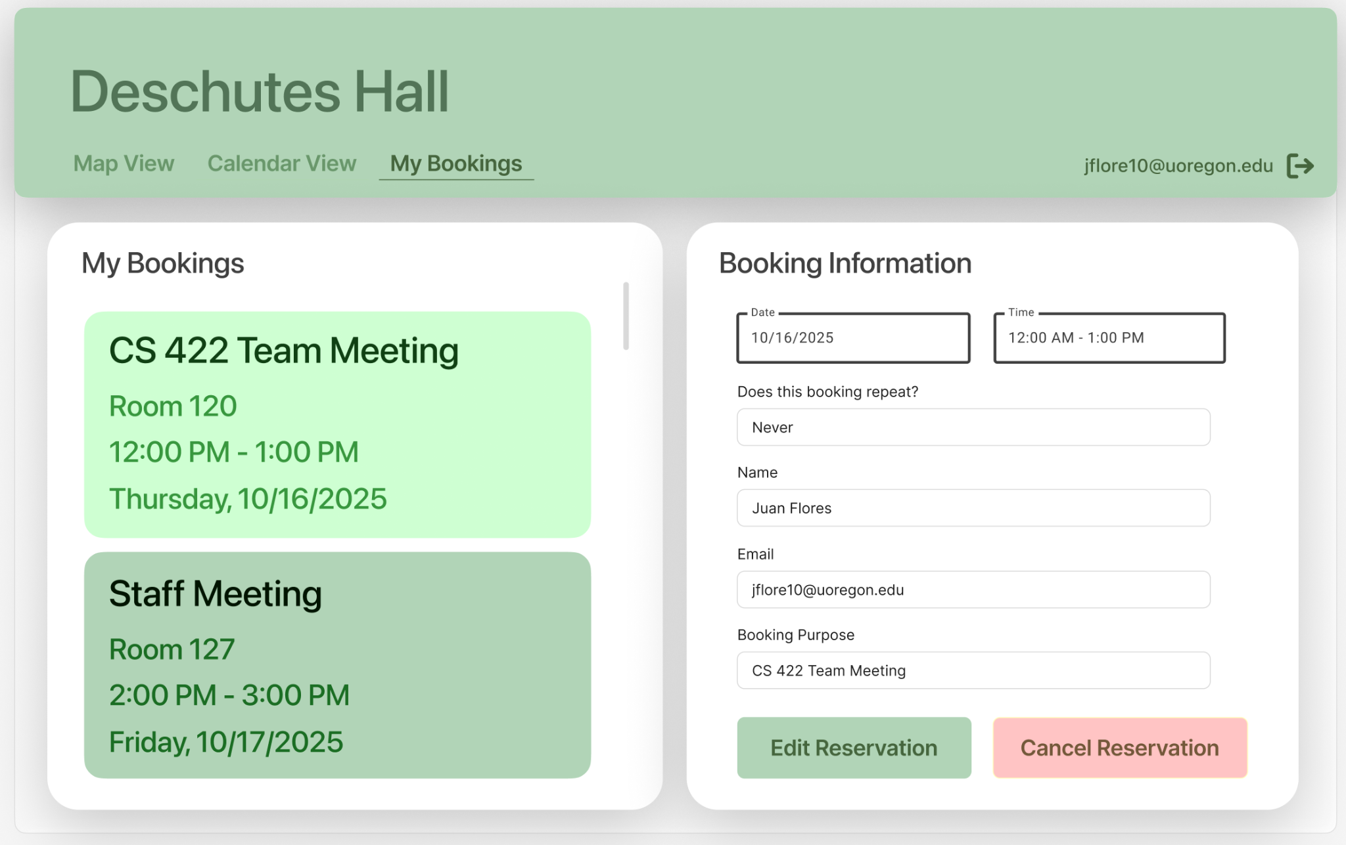
Figure 5. My Bookings View

2.4. User Classes
The proposed system will have three primary user classes: administrators, faculty, and students. These classes differ in responsibilities, system access, and the ways they interact with the platform.
- Administrators.
Administrators have full system access and are responsible for overseeing all room reservations within Deschutes Hall as well as building and room access. Their permissions include viewing, approving, denying, editing, and canceling any reservation in the system. Administrators can also configure global system settings, such as building hours, and room data (capacity, equipment, availability).
Administrators have the highest level of access to the “All Bookings” page, which provides a comprehensive overview of all reservations and additional tools. They can perform management actions directly from the interface such as editing or deleting bookings. Administrators also maintain the database of users and can modify roles or add/delete users as needed.
- Faculty.
Faculty members can reserve rooms for academic or departmental purposes, such as classes, meetings, research groups, etc.. They can view the full list of bookings across all rooms with full information of the reservation (room, time, and purpose) and make reservations without requiring administrator approval. Faculty members will also receive automated confirmation emails and have the ability to modify or cancel their reservations directly through the system.
- Student.
Students interact with the system to reserve rooms for study sessions, group office hours, group projects, or club meetings. They can view available rooms and submit reservation requests, though bookings require approval from an administrator. They can view the full list of bookings across all rooms with limited information of the reservation (room, and time only).
Each user class will interact with the system through role-specific rules, ensuring that tasks such as booking, managing, and overseeing reservations are performed while maintaining system security and data integrity.

2.5. Modes of Operation
The Deschutes room reservation system will operate in a single normal operation mode. In this mode, all users can access the system according to their assigned roles. Administrators can manage rooms and users, update information, and handle reservations for all users. Faculty can view and reserve rooms without requiring administrator approval, meanwhile students can view reservations in a limited manner and submit booking requests for approval. This mode supports all core system functionality.

2.6. Operational Scenarios (Use Cases)
Use Case 1: Viewing Room Availability
Brief description: This use case describes how a user views available rooms and time slots to plan a potential reservation.
Actors: Administrator, faculty, student
Preconditions:
1. The user has successfully logged into the system and authenticated themselves.
2. The system is operating in its normal mode and has up-to-date room data.
Steps to Complete the Task:
- The user selects the “Map View” (Figure 3) or “Calendar View” (Figure 4) option from the main dashboard.
- The system displays a calendar or map view of all rooms.
- The user filters or searches by date, time, or room.
- The system displays available rooms matching the selected criteria.
Postconditions:
The user can clearly see room availability and proceed to make a reservation if desired.

Use Case 2: Creating a Room Reservation
Brief description: This use case describes how a user creates a new room reservation using the system.
Actors: Administrator, faculty, student
Preconditions:
- The user is logged in and has permission to reserve a room.
- The user has reviewed room availability.
Steps to Complete the Task:
- The user selects an available time slot and room.
- The user navigates to the “Book Room” widget on the same page and enters required information (date, start and end, whether the booking repeats, and purpose while name and email are autofilled).
- The system checks for scheduling conflicts.
- If a conflict is found, the system alerts the user and suggests alternative times
- If no conflict is found, the user confirms and submits the reservation request.
- The system generates a confirmation message and sends a detailed confirmation email.
Postconditions:
The reservation is successfully created and stored in the system. Faculty and administrator reservations are immediately confirmed, while student reservations await administrator approval depending on the room.

Use Case 3: Modifying or Canceling a Reservation
Brief description: This use case describes how users modify or cancel an existing reservation.
Actors: Administrator, faculty, student
Preconditions:The user has an active reservation in the system.
- The user is logged in and has the appropriate access permissions.
Steps to Complete the Task:
- The user navigates to “My Bookings” from their dashboard.
- The system displays all reservations associated with the user.
- The user selects the reservation they wish to modify or cancel.
- The user updates details (e.g., time, purpose) or selects “Cancel Reservation.”
- The system validates changes, ensuring no conflicts exist.
- The system updates the reservation and sends an updated confirmation email.
Postconditions:
The reservation is successfully modified or canceled, and system data is updated accordingly. Students may need edits approved by the administrator but this is implemented only if time allows.

Use Case 4: Email Confirmation Workflow
Brief description: This use case describes how the system automatically generates and sends confirmation and cancellation emails to users after booking actions are performed. These emails contain reservation details and direct links for modification or cancellation.
Actors: System (automated) and any authenticated user (administrator, faculty, or student)
Preconditions:
- The user has completed a valid booking, modification, or cancellation request.
- The system has access to the user’s UO-verified email address through Firebase Authentication.

Steps to Complete the Task:
- After a reservation action (creation, modification, or cancellation), the system retrieves the relevant booking information from the Firestore database.
- The system formats an email containing details such as room number, date, time, duration, and purpose. (contents of what this email will fully look like may differ with the final outcome)
- The system sends the email automatically to the user’s UO email address.
Postconditions:
The user receives a clear, formatted confirmation or cancellation email reflecting the latest booking status. The system ensures that Firestore data and user interfaces are consistent with the confirmed action.

Specific Requirements

3.1. External Interfaces (Inputs/Outputs)

3.1.1 Viewing and Creating Room Reservations
- Purpose: To allow users to view available rooms and times, and to create new reservations based on room availability.
- Source of input/source of output: Input includes user selection of date, time, and room from the calendar or map view, along with reservation details such as purpose, recurrence, and duration. Output displays available and unavailable rooms on-screen, and upon booking, provides a confirmation message and email notification.
- Valid ranges of input/output: Date must be within building operating hours and a valid future date; room selection must match existing room records;. Output displays valid, non-conflicting room options or alerts the user of conflicts.
- Units of measure: Time in hours/minutes; capacity in number of people.
- Data formats: User input and database transactions use JSON. Output is rendered dynamically in HTML and via formatted HTML email notifications.

3.1.2 Modifying and Canceling Reservations
- Purpose: To allow users to update or remove existing reservations after creation.
- Source of input/source of output: Input includes user actions to edit reservation details (e.g., date, time, duration) or to cancel a reservation from the “My Bookings” page. Output is a confirmation message displayed on-screen and a follow-up email confirming the modification or cancellation.
- Valid ranges of input/output: Only active reservations may be modified or canceled; changes must not overlap with existing bookings. Output confirms successful updates or cancellation, or provides an error message if invalid.
- Units of measure: Time in hours/minutes.
- Data formats: JSON-formatted request and plain-text or HTML confirmation email.

3.1.3 Confirmation and Notification Emails
- Purpose: To notify users about reservation confirmations, modifications, and cancellations.
- Source of input/source of output: Input is a system event (reservation action). Output is an email sent to the user’s UO email address.
- Valid ranges of input/output: Triggered automatically upon valid reservation actions. Output includes room number, date, time, and purpose.
- Units of measure: Time in hours/minutes; capacity as number of people.
- Data formats: HTML.

3.1.4 Authentication Interface
- Purpose: To authenticate users and assign access levels (administrator, faculty, student).
- Source of input/source of output: Input is user credentials via UO Shibboleth or Firebase Authentication (or may be some other option depending on conversations with stakeholders). Output is a verified login status, assigned role, and user dashboard.
- Valid ranges of input/output: Valid UO credentials required. Unauthorized users are denied the ability to create bookings but may still view current bookings and availability in a highly limited manner to protect privacy.
- Units of measure: Not applicable.
- Data formats: Authentication tokens in JSON Web Token (JWT) format handled through Firebase Auth SDK or another option depending on discussion with stakeholders.

3.2. Functions
3.2.1 Validity checks on the inputs:
The system will verify that all user inputs meet the required constraints before processing.
- Login credentials must match an existing registered user with valid University of Oregon (.uoregon.edu).
- Reservation inputs must include a valid room ID, date, time, and duration within building operating hours.
- Overlapping reservations will be automatically rejected, and users will be prompted to select a different time or room.
3.2.2 Sequence of operations in processing inputs:
- The user signs in using UO credentials.
- The system loads the site with appropriate access.
- The user selects a date and time from the map or calendar view.
- The system queries Firestore for room availability and filters results.
- The user submits the booking form; the system validates and stores the data in Firestore.
- A confirmation message appears, and an HTML email is sent.
- For modifications or cancellations, the system updates Firestore and emails the user confirmation of changes.
- Note: Students require approval from admin while all other users are automatically approved.
3.2.3 Responses to abnormal situations, including error handling and recovery:
- If a reservation request conflicts with an existing booking or contains invalid fields (e.g., missing time or incorrect date format), the system displays an error alert and prevents submission until corrected.

3.3. Usability Requirements
The Deschutes hall room reservation system will be designed to be simple and easy for anyone to use whether they are a student, faculty member, or administrator. Users should be able to quickly figure out how to view available rooms, make reservations, and manage their bookings. There is an instruction card accessed via the “Instructions” button with further guidance if the site itself is non-intuitive. The system will include clear labels to help guide users through each step. If a user makes an error, such as entering an invalid time or trying to book a full room, the system will display an easy-to-understand message explaining what went wrong and how to fix it. The goal is for any user to feel comfortable using the system, and to be able to complete basic tasks like booking or canceling a room in just a few minutes.

3.4. Performance Requirements
The Deschutes Room Reservation System will be designed for simplicity and accessibility across all user types, featuring an intuitive interface with interactive SVG maps, calendar displays, and clearly labeled forms. When a user submits a reservation, the system should confirm it almost immediately, with most actions completed in less than five seconds. It is crucial to note that some actions (ex. creating a repeat booking that creates a significant number of reservations) may take a few seconds to process. The system will be able to handle multiple users at once, allowing students, faculty, and administrators to view and make reservations without noticeable slowdowns. Room data and reservation details will be stored and updated in real time so that availability stays accurate. The interface will be fully responsive and tested for compatibility across modern browsers including Chrome, Firefox, and Safari. Visual indicators such as color-coded room statuses will provide immediate feedback on room availability. Overall, users will be able to complete essential tasks, such as creating or canceling a reservation, in just a few clicks from the main dashboard.

3.5. Software System Attributes
The Deschutes hall room reservation system will focus on being reliable, secure, and easy to maintain. Reliability is important because students and faculty need to trust that the system will always show accurate room information and that reservations will save correctly. To achieve this, the system will be tested thoroughly to make sure it runs smoothly and doesn’t crash during normal use. Security will be enforced through authenticated user access and strict role-based permissions to prevent unauthorized modifications or data exposure. To support maintainability, all code will be version-controlled in a shared GitHub repository, with clearly defined module ownership and regularly updated documentation tracked through Jira. Finally, the system will be designed to be easy to update and maintain, so that future improvements can be made without major changes to the whole system.

References
University of Oregon. (n.d.). Student Computing: Services and support. Student Computing & Digital Spaces (SCDS). Retrieved October 16, 2025, from https://scds.uoregon.edu/#:~:text=230,students%20served%20across%20campus%20annually

Acknowledgements
The SRS template was provided by Juan Flores, who changed the original document created by
Anthony Hornof.

